College Study Material Management System

## ***By***

#### *Vedant Snehalkumar Patel*

**Sardar Vallabhbhai Patel Institute of Technology**

#### Bachelor in Engineering

**SAP Educate to Employ (E2E) Software Development Track**

# Index

#### Project Description

1. **Database Schema (Persistence Layer)**
   1. *ZUSER_LOGIN*
   2. *ZSTUDY_MATERIAL*
   3. *ZDEPARTMENT*
   4. *ZFACULTY*
   5. *ZSTUDENT_1535*

#### Core Functionality (ABAP Classes)

* 1. *ZADD_USER_LOGIN_DATA – User Login Data*
  2. *ZADD_STUDY_MATERIAL – Add Material*
  3. *ZADD_DEPARTMENT_DATA* ***-****Add Department Data*
  4. *ZADD_FACULTY_DATA– Add Faculty Data*
  5. *ZADD_STUDENT_DATA– Add Student Data*
  6. *ZCL JOIN DEMO– Performing Join Operation*
  7. *ZCL_AGGREGATE DEMO– Performing Aggregate Functions (Code Pushdown)*
  8. *ZCL SUBQUERY_DEMO– Concept of Subquery*
  9. *ZCL FUNCTIONS_DEMO– Performing In-built Functions*

#### SQL Usage

* 1. *ZCL_JOIN_DEMO – Performing Join Operation*
  2. *ZCL_AGGREGATE_DEMO – Performing Aggregate Function (Code Pushdown)*
  3. *ZCL_SUBQUERY_DEMO – Concept of Subquery*
  4. *ZCL_FUNCTION_DEMO – Performing In-built Function*

#### Service Definition & Binding

* 1. *Service Definitions*
  2. *Service Bindings*
     1. *Type: OData V4*
     2. *Exposed Entities*

#### CDS Views (Data Model Layer)

* 1. **Interface Views (ZR_*)***

1. *ZR_USER_LOGIN ZCL FUNCTIONS_DEMO Behavior Definition for ZR_USER_LOGIN*
2. *ZR_STUDY_MATERIAL000 – Behavior Definition for ZR_STUDY_MATERIAL*
3. *ZR_DEPARTMENT – Behavior Definition for ZR_DEPARTMENT*
4. *ZR_FACULTY– Behavior Definition for ZR_FACULTY*
5. *ZR_STUDENT_1535 – Behavior Definition for ZR_STUDENT_1535*
   * 1. ***Projection Views (ZC_*)**
6. *ZC_USER_LOGIN –Projection Behavior Definition for ZC_USER_LOGIN*
7. *ZC_STUDY_MATERIAL000 – Projection Behavior Definition for ZC_STUDY_MATERIAL*
8. *ZC_DEPARTMENT000 – Projection Behavior Definition for ZC_DEPARTMENT*
9. *ZC_FACULTY– Projection Behavior Definition for ZC_FACULTY*
10. *ZC_STUDENT_1535 – Projection Behavior Definition for ZC_STUDENT_1535*

#### RESTful Implementation Linked to Specific Tables

* 1. *User Login Details*
  2. *Study Material Details*
  3. *Department Details*
  4. *Faculty Details*
  5. *Student Details*

#### Final Outcome

1. **Conclusion**
2. **Project Description**

**Overview**

#### *This SAP ABAP-based project manages college study materials for students and faculty. It includes modules for student and faculty data, subject and department linkage, semester-wise study material uploads, and a secure login system for both roles. Faculty can upload materials by subject and semester, while students can log in to view and download relevant content. The system uses transparent tables and ABAP class logic for efficient data handling.*

#### Key entities in the system include:

* **Student Master Data**  
  *Stores personal and academic information such as name, enrolment number, course, and department.*
* **Faculty Master Data**  
  *Contains faculty details including name, designation, department, and contact information.*
* **Study Material Database**  
  *Holds data about the material uploaded by faculty, such as file path, type (PDF, PPT, DOC), subject, and upload metadata.*
* **Course and Subject Management**  
  *Allows linking of study material with courses and subjects, including semester-specific data.*
* **Login Table (zuser_login)**  
  *Maintains secure login credentials for both students and faculty, with role-based access (STUDENT / FACULTY), encrypted passwords (hashed for real-world use), and email-based identification.*

### ****Key Features****

* **User Roles:** *Separate login and access for students and faculty.*
* **Study Material Upload:** *Faculty can upload documents by subject, department, and* *semester.*
* **Secure Authentication:** *Login with password, role-based access control.*
* **Organized Data Tables:** *Transparent tables for faculty, students, departments, and study materials.*
* **Semester-wise Structure:** *Materials and students are managed semester-wise.*
* **Document Access:** *Students can access and download relevant materials anytime*.
* **Clean UI (if using RESTful app):** *Simple and accessible interface for all users.*

### ****Benefits****

* **Centralized Access:** *All materials in one structured database.*
* **Time-Saving:** *Eliminates the need for manual distribution of notes.*
* **Data Security:** *Role-based logins ensure authorized access.*
* **Scalable:** *Easily extendable to multiple departments and semesters.*
* **User-Friendly:** *Simplified experience for uploading and accessing resource.*

**PROJECT STRUCTURE**

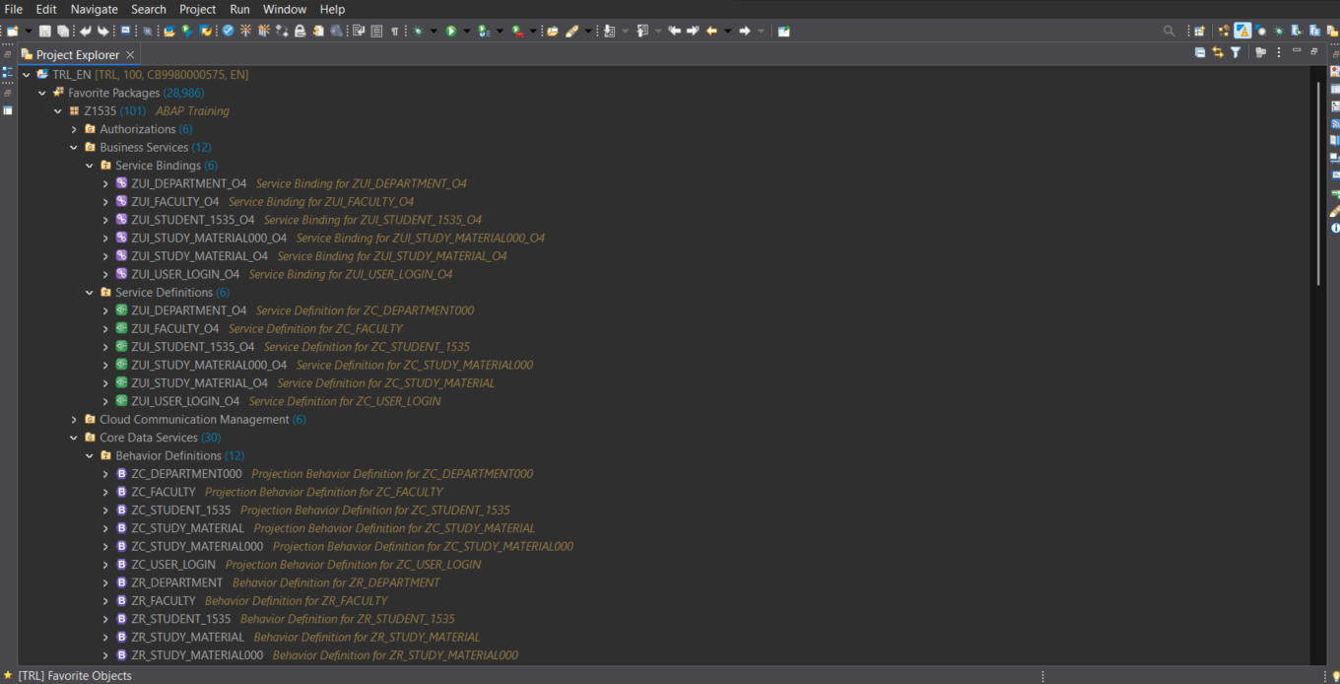

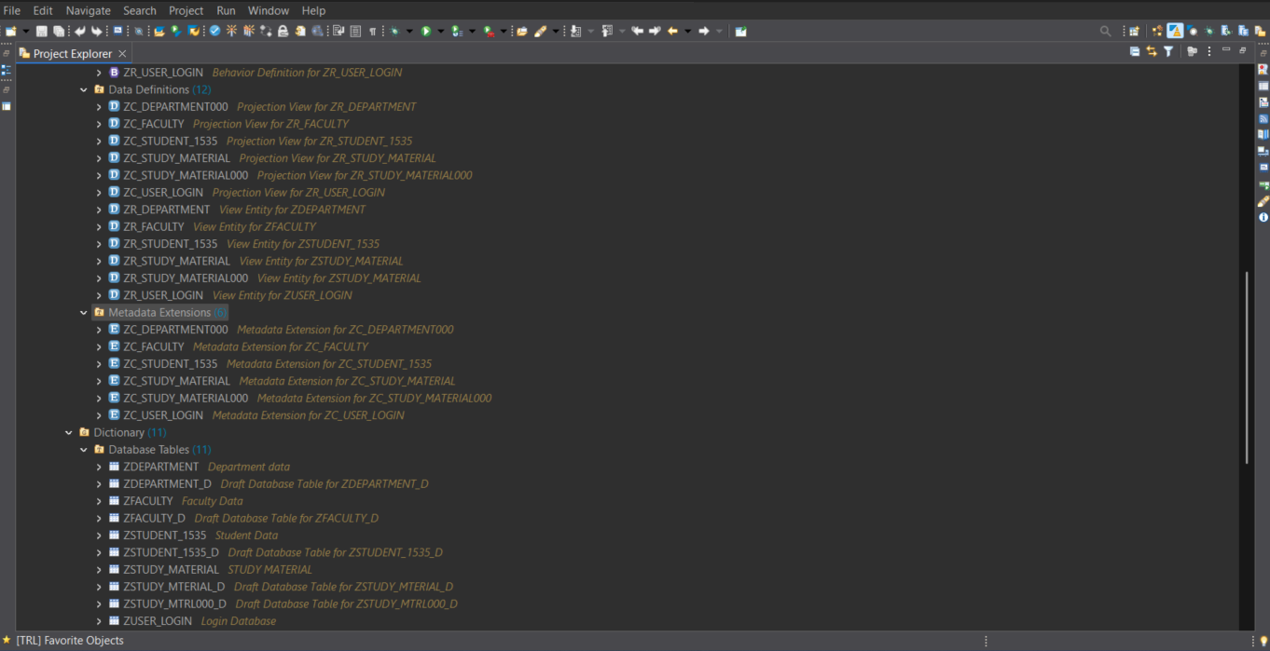

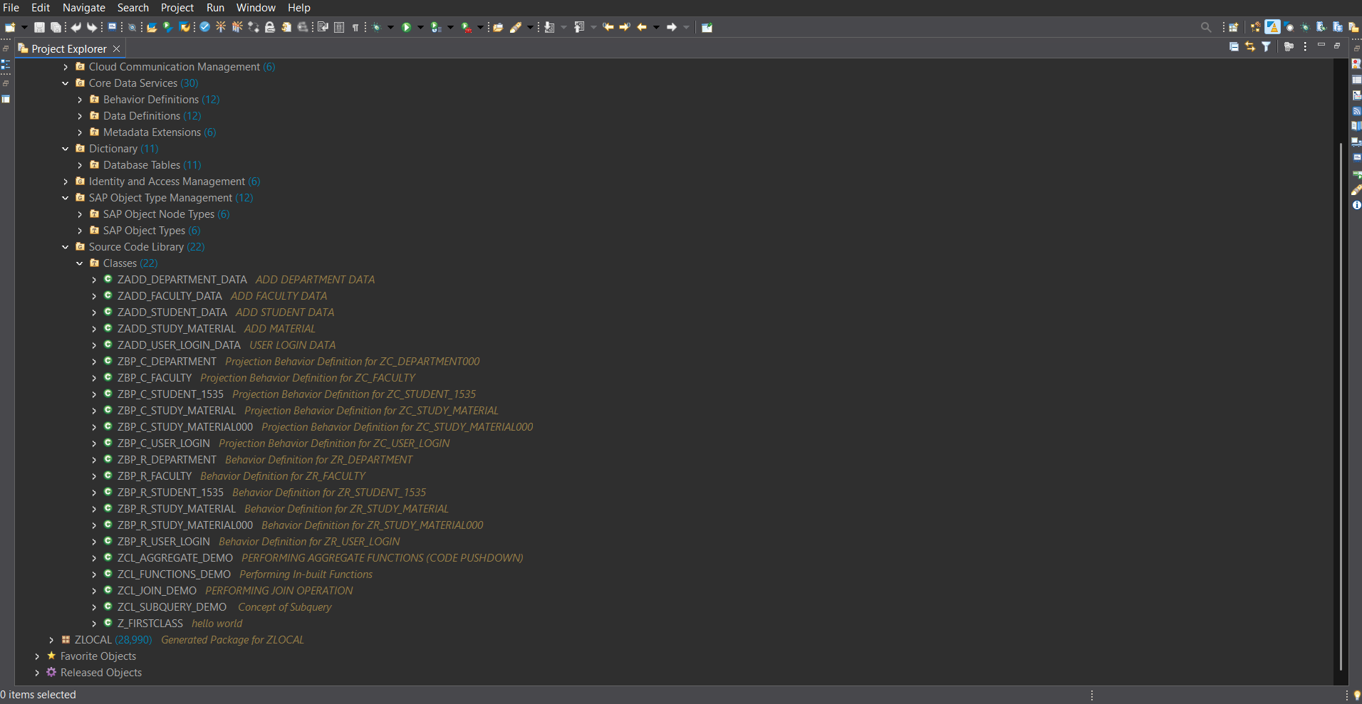

## **Database Schema (Persistence Layer)**

## ***ZUSER_LOGIN***

| **Field Name** | **Data Type** | **Description** |
| --- | --- | --- |
| client | abap.clnt | Client Key |
| user_id | abap.char(12) | User ID (Student/Faculty) |
| role | abap.char(10) | Role (student/faculty) |
| password | abap.char(40) | Hashed Password |
| last_login | abap.dats | Last Login Date |
| email | abap.char(100) | Email Address |
| createdby | abp_creation_user | Created By |
| changedby | abp_lastchange_user | Changed By |
| lastchangedat | abp_lastchange_tstmpl | Last Changed Timestamp |
| locallastchangedat | abp_locinst_lastchange_tstmpl | Local Last Changed Timestamp |

## 

***2.2 ZSTUDY_MATERIAL***

| **Field Name** | **Data Type** | **Description** |
| --- | --- | --- |
| client | abap.clnt | Client Key |
| mat_id | abap.char(10) | Unique Material ID |
| title | abap.char(100) | Title of the Study Material |
| subject | abap.char(50) | Subject Name |
| file_name | abap.char(255) | Uploaded File Name |
| file_content_type | abap.char(10) | File MIME Type (e.g., PDF, DOCX) |
| file_url | abap.char(255) | File URL / Storage Path |
| dept_id | abap.char(10) | Department ID |
| semester | abap.numc(2) | Semester Code (e.g., 01, 02) |
| createdby | abp_creation_user | Created By |
| changedby | abp_lastchange_user | Changed By |
| lastchangedat | abp_lastchange_tstmpl | Last Changed Timestamp |
| locallastchangedat | abp_locinst_lastchange_tstmpl | Local Last Changed Timestamp |

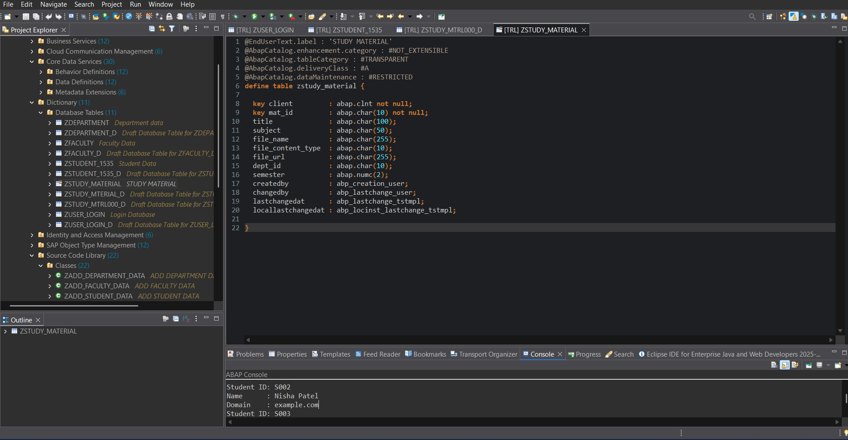

***2.3 ZDEPARTMENT***

| **Field Name** | **Data Type** | **Description** |
| --- | --- | --- |
| client | abap.clnt | Client Key |
| dept_id | abap.char(10) | Department ID (Primary Key) |
| dept_name | abap.char(50) | Department Name |
| dept_code | abap.int4 | Department Code (Numeric) |
| createdby | abp_creation_user | Created By |
| changedby | abp_lastchange_user | Changed By |
| lastchangedat | abp_lastchange_tstmpl | Last Changed Timestamp |
| locallastchangedat | abp_locinst_lastchange_tstmpl | Local Last Changed Timestamp |

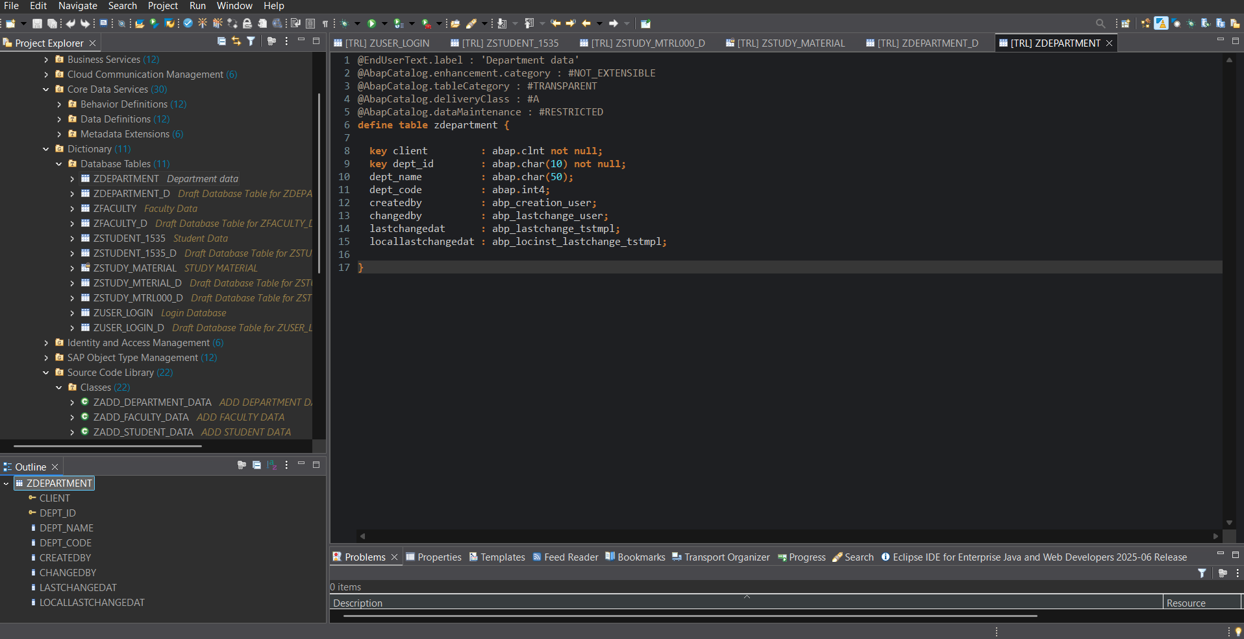

***2.4 ZFACULTY***

| **Field Name** | **Data Type** | **Description** |
| --- | --- | --- |
| client | abap.clnt | Client Key |
| faculty_id | abap.char(10) | Unique Faculty ID |
| name | abap.char(100) | Faculty Full Name |
| email | abap.char(100) | Email Address |
| phone | abap.char(15) | Contact Phone Number |
| dept_id | abap.char(10) | Department ID (Foreign Key) |
| designation | abap.char(25) | Job Title or Designation |
| createdby | abp_creation_user | Created By |
| changedby | abp_lastchange_user | Changed By |
| lastchangedat | abp_lastchange_tstmpl | Last Changed Timestamp |
| locallastchangedat | abp_locinst_lastchange_tstmpl | Local Last Changed Timestamp |

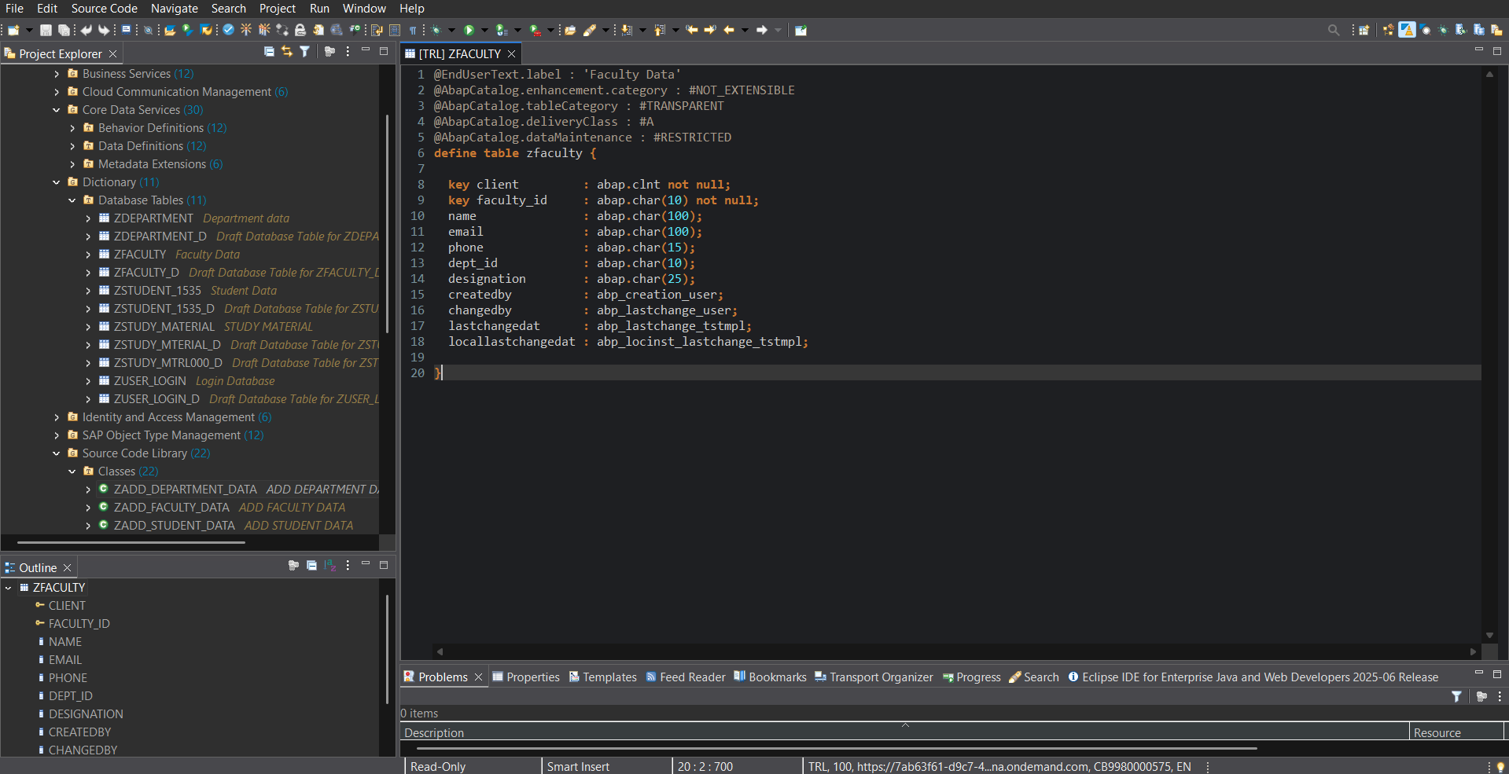

***2.5 ZSTUDENT_1535***

| **Field Name** | **Data Type** | **Description** |
| --- | --- | --- |
| client | abap.clnt | Client Key |
| student_id | abap.char(10) | Unique Student ID (Primary Key) |
| name | abap.char(100) | Full Name of the Student |
| gender | abap.char(1) | Gender (M/F/O) |
| dob | abap.dats | Date of Birth |
| email | abap.char(100) | Email Address |
| phone | abap.char(15) | Contact Phone Number |
| enrollment_no | abap.numc(12) | University Enrollment Number |
| dept_id | abap.char(10) | Department ID (Foreign Key) |
| semester | abap.numc(2) | Current Semester |
| createdby | abp_creation_user | Created By |
| changedby | abp_lastchange_user | Changed By |
| lastchangedat | abp_lastchange_tstmpl | Last Changed Timestamp |
| locallastchangedat | abp_locinst_lastchange_tstmpl | Local Last Changed Timestamp |

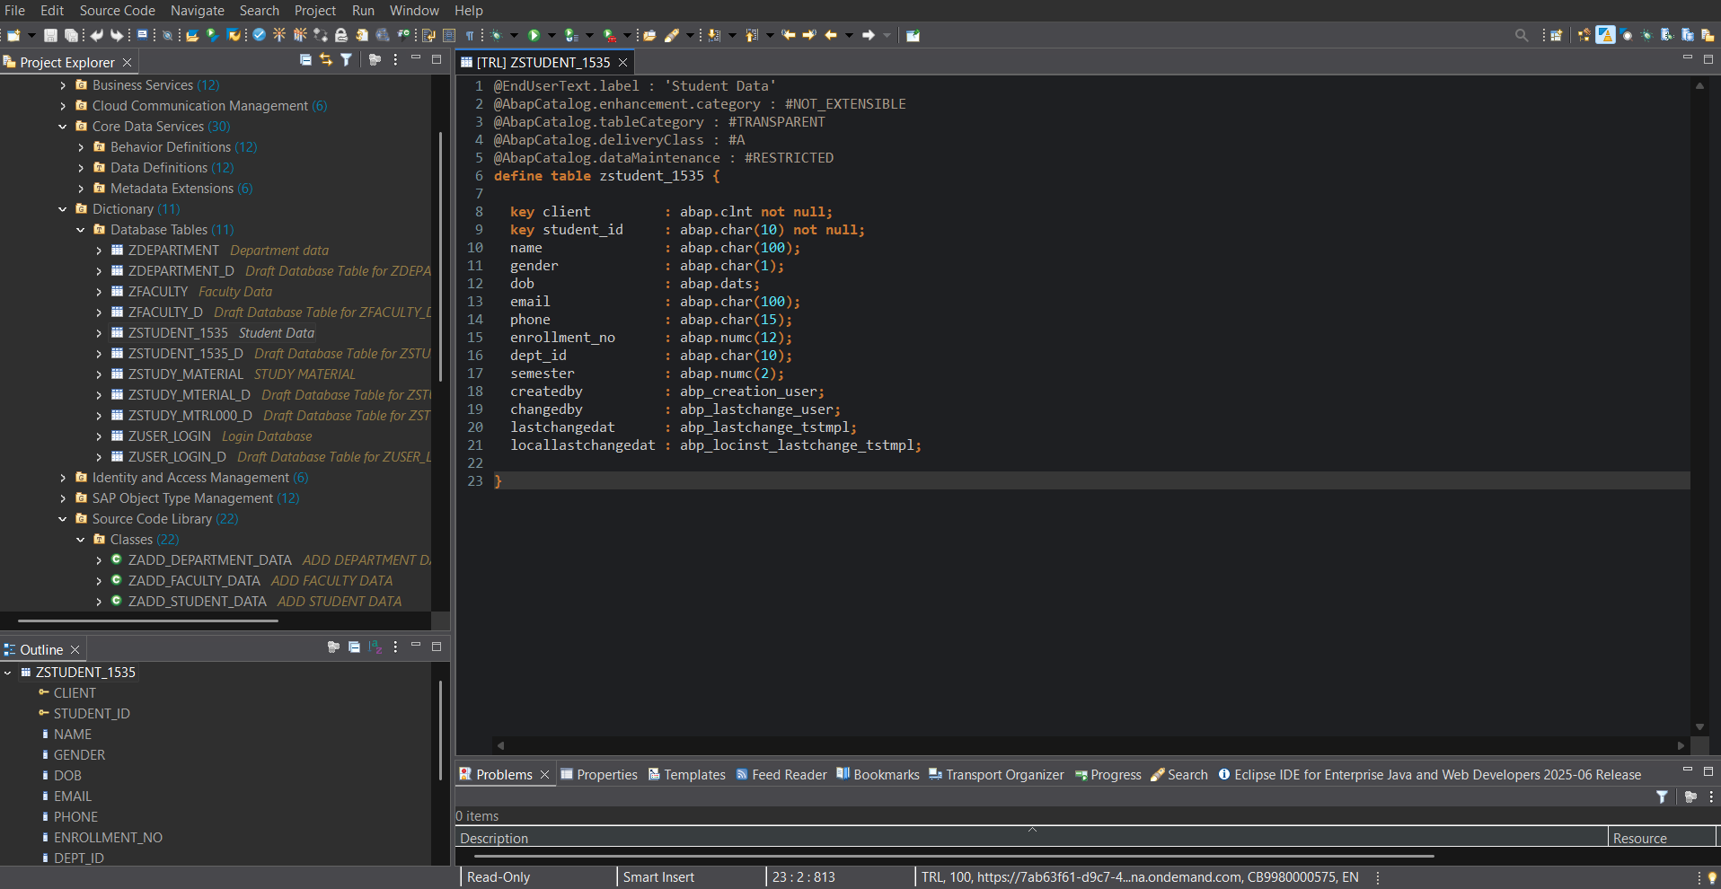

1. **Core Functionality (ABAP Classes)**
   1. ***ZADD_USER_LOGIN_DATA – User Login Data***

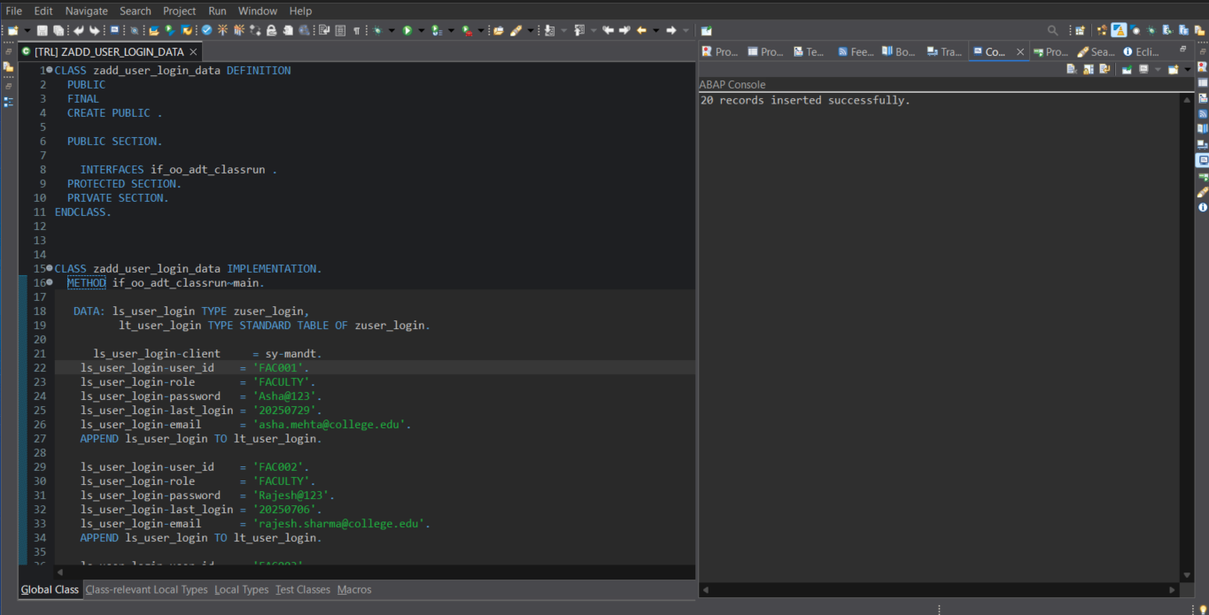

* 1. ***ZADD_STUDY_MATERIAL – Add Material***

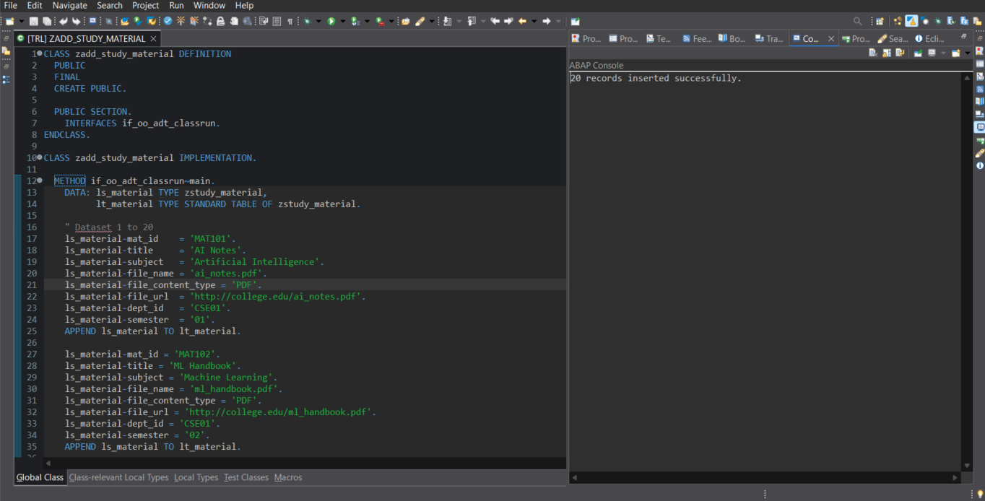

* 1. ***ZADD_DEPARTMENT_DATA -Add Department Data***

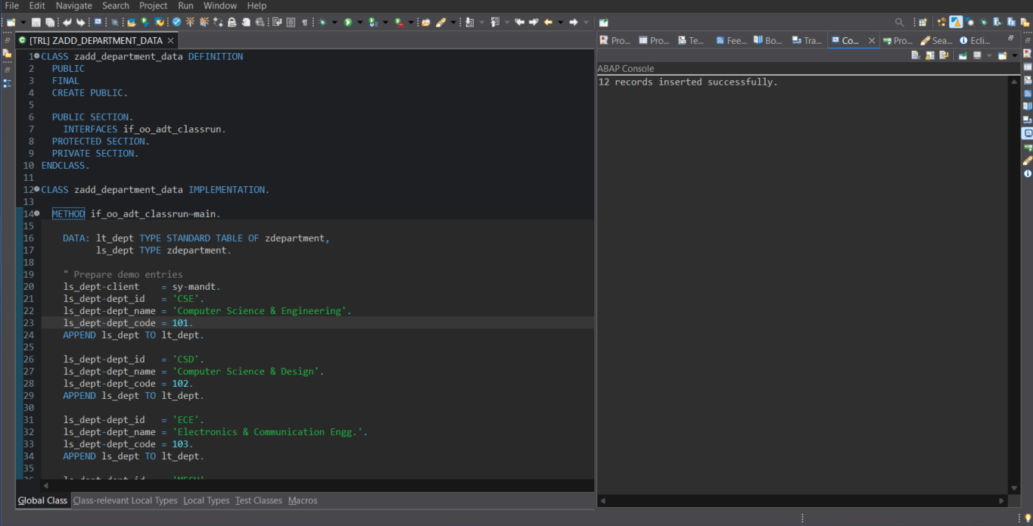

* 1. ***ZADD_FACULTY_DATA– Add Faculty Data***

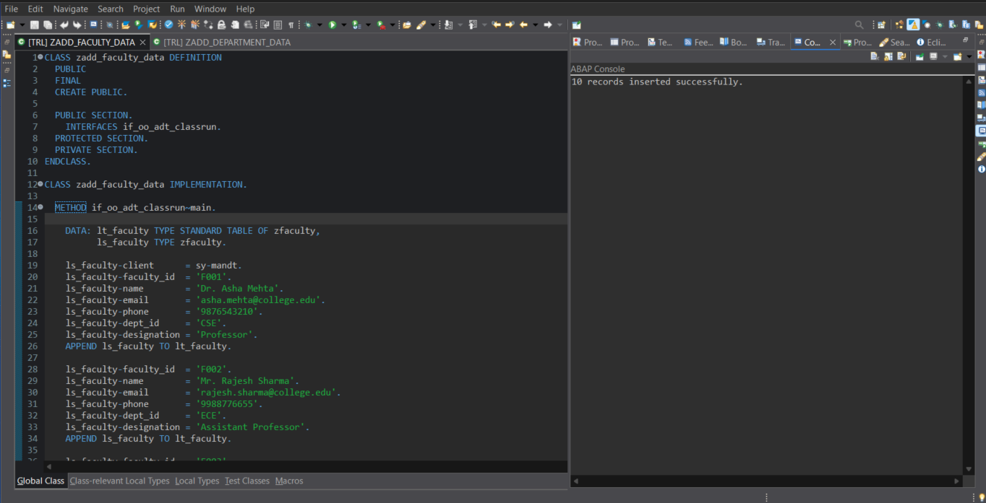

* 1. ***ZADD_STUDENT_DATA– Add Student Data***

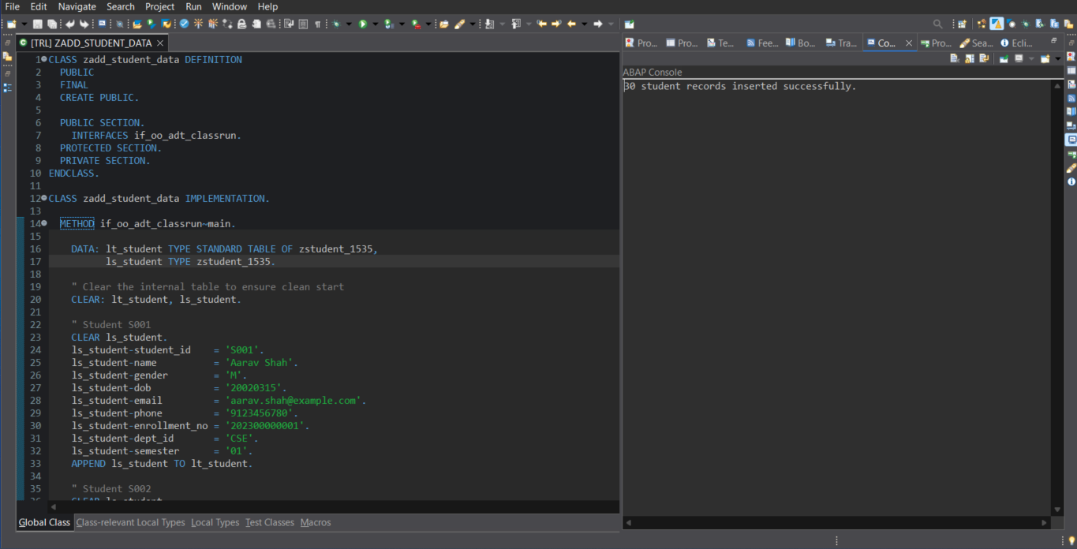

* 1. ***ZCL JOIN DEMO– Performing Join Operation***

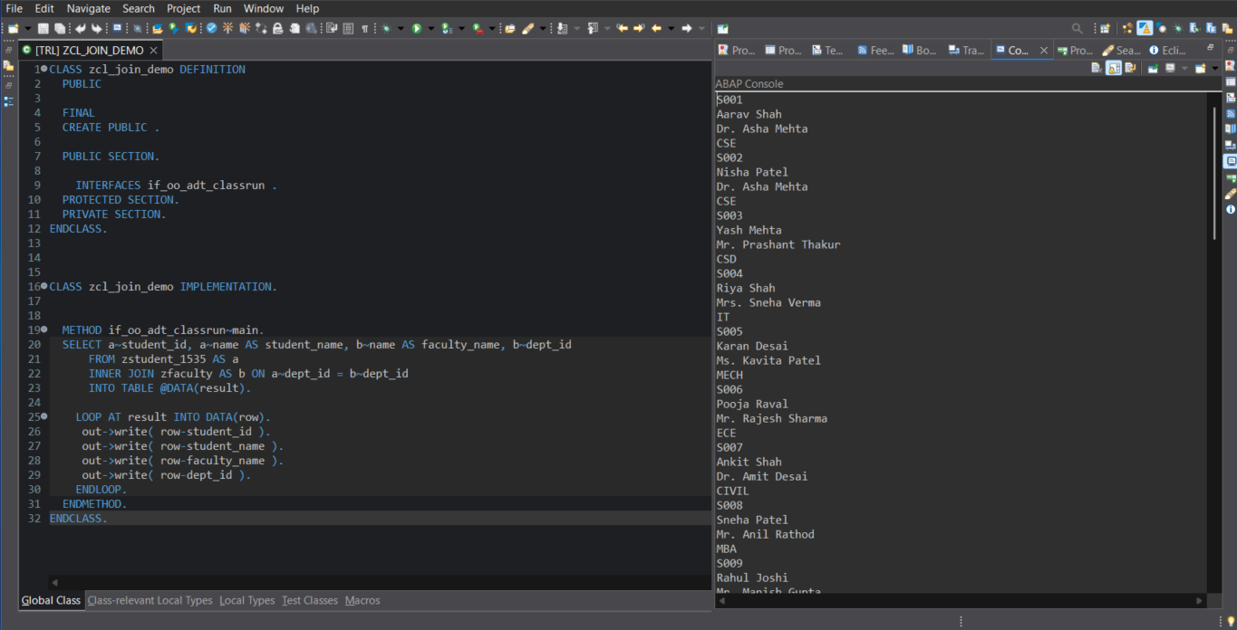

* 1. ***ZCL_AGGREGATE DEMO– Performing Aggregate Functions (Code Pushdown)***

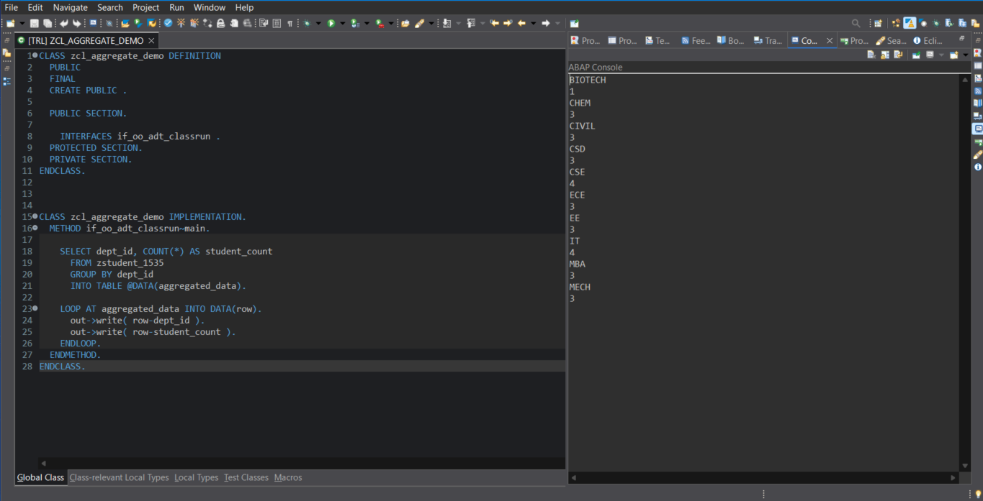

* 1. ***ZCL SUBQUERY_DEMO– Concept of Subquery***

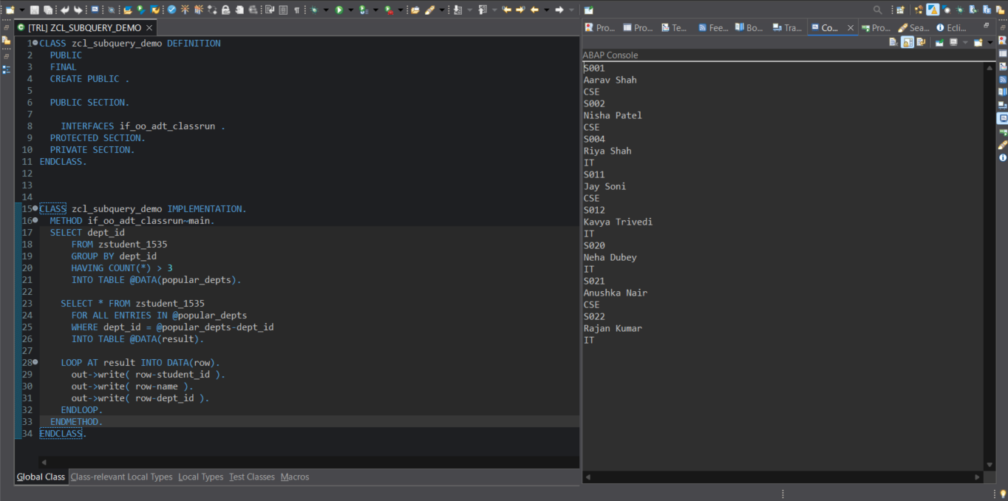

* 1. ***ZCL FUNCTIONS_DEMO– Performing In-built Functions***

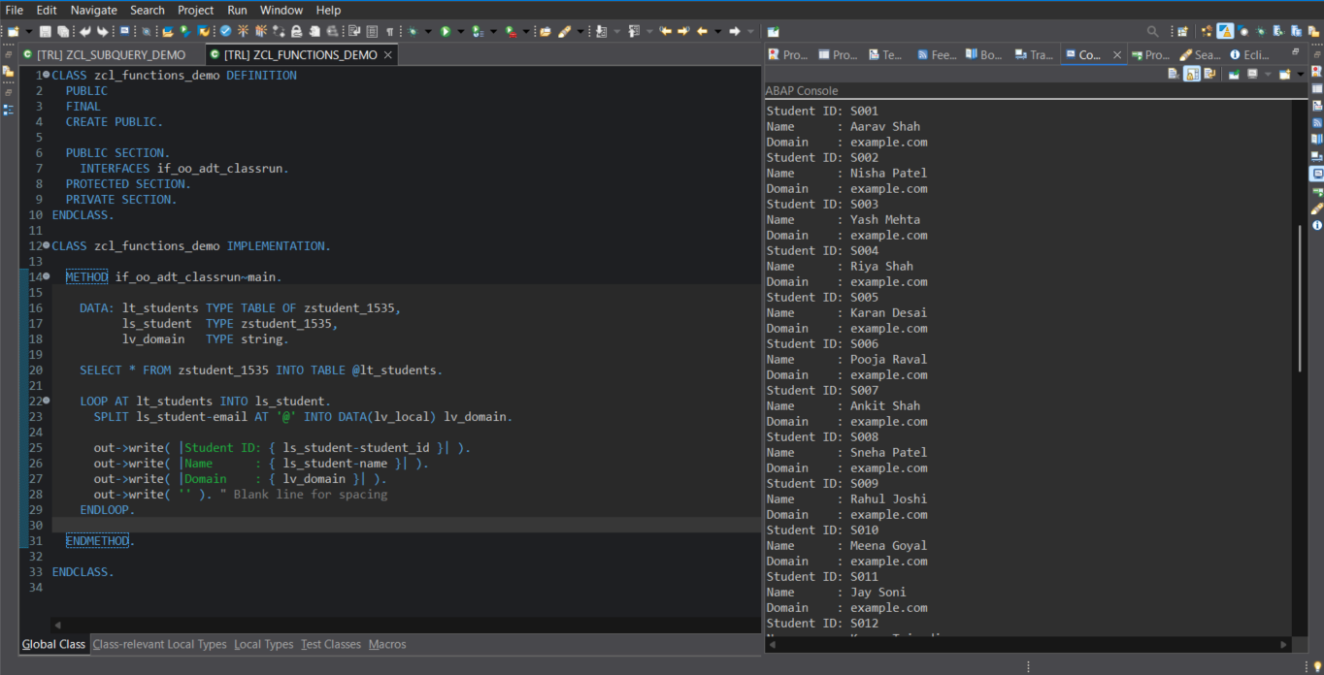

1. **SQL Usage**
2. ***Performing Join Operation***

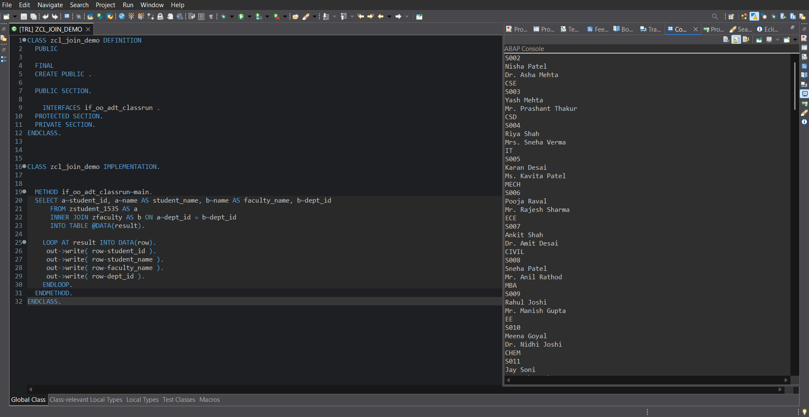

### *****Performing Aggregate Functions (Code Pushdown)*****

### 

### *Concept of Subquery*

# 

# *Performing In-built Functions*

# 

# Service Definition & Binding

* **Service Definition:**

1. *ZUI_DEPARTMENT_O4*
2. *ZUI_FACULTY_O4*
3. *ZUI_STUDENT_1535_O4*
4. *ZUI_STUDY_MATERIAL000_O4*
5. *ZUI_USER_LOGIN_O4*

* **Service Binding:** 
  + - 1. *ZUI_DEPARTMENT_O4*
      2. *ZUI_FACULTY_O4*
      3. *ZUI_STUDENT_1535_O4*
      4. *ZUI_STUDY_MATERIAL000_O4*
      5. *ZUI_USER_LOGIN_O4*
  + Type: OData V4
  + Entities exposed:
  1. *User Login Details*
  2. *Study Material Details*
  3. *Department Details*
  4. *Faculty Details*
  5. *Student Details*

#### CDS Views (Data Model Layer)

* 1. **Interface Views (ZR_*)***
     1. *ZR_USER_LOGIN ZCL FUNCTIONS_DEMO Behavior Definition for ZR_USER_LOGIN*

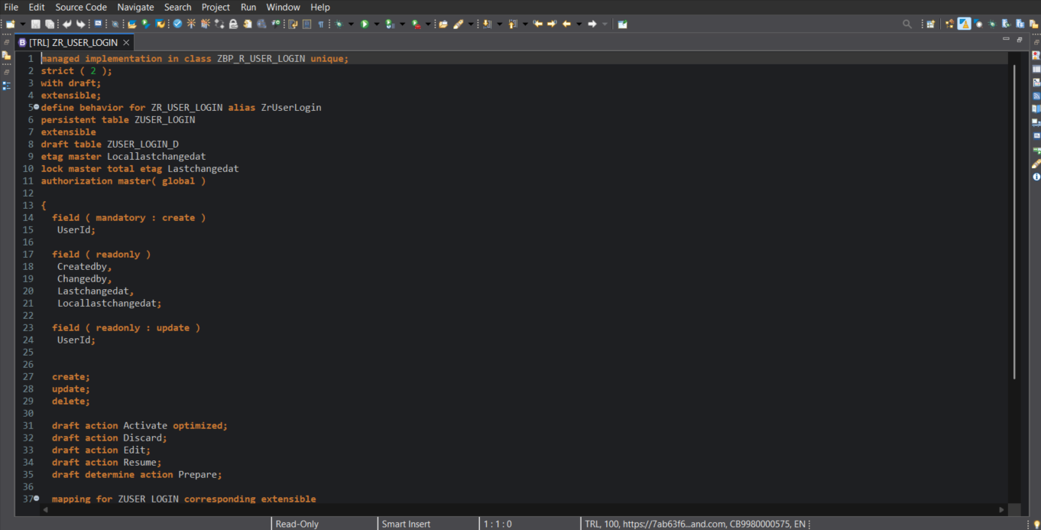

* + 1. *ZR_STUDY_MATERIAL000 –Behavior Definition for ZR_STUDY_MATERIAL*

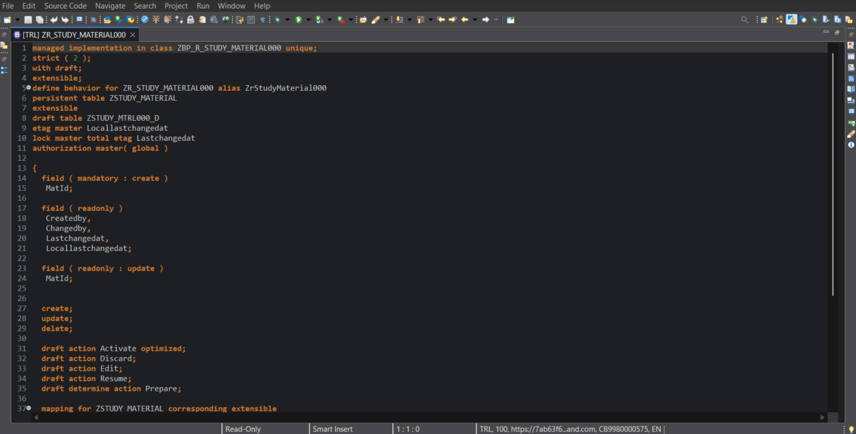

* + 1. *ZR_DEPARTMENT – Behavior Definition for ZR_DEPARTMENT*

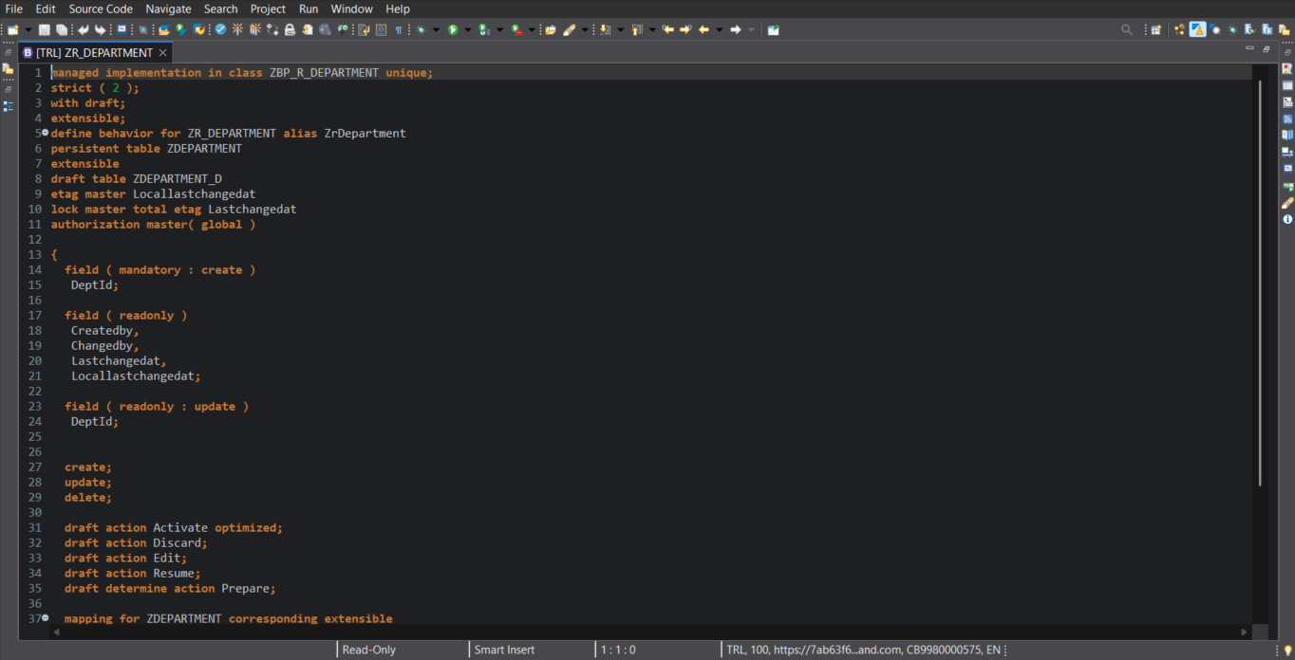

* + 1. *ZR_FACULTY– Behavior Definition for ZR_FACULTY*

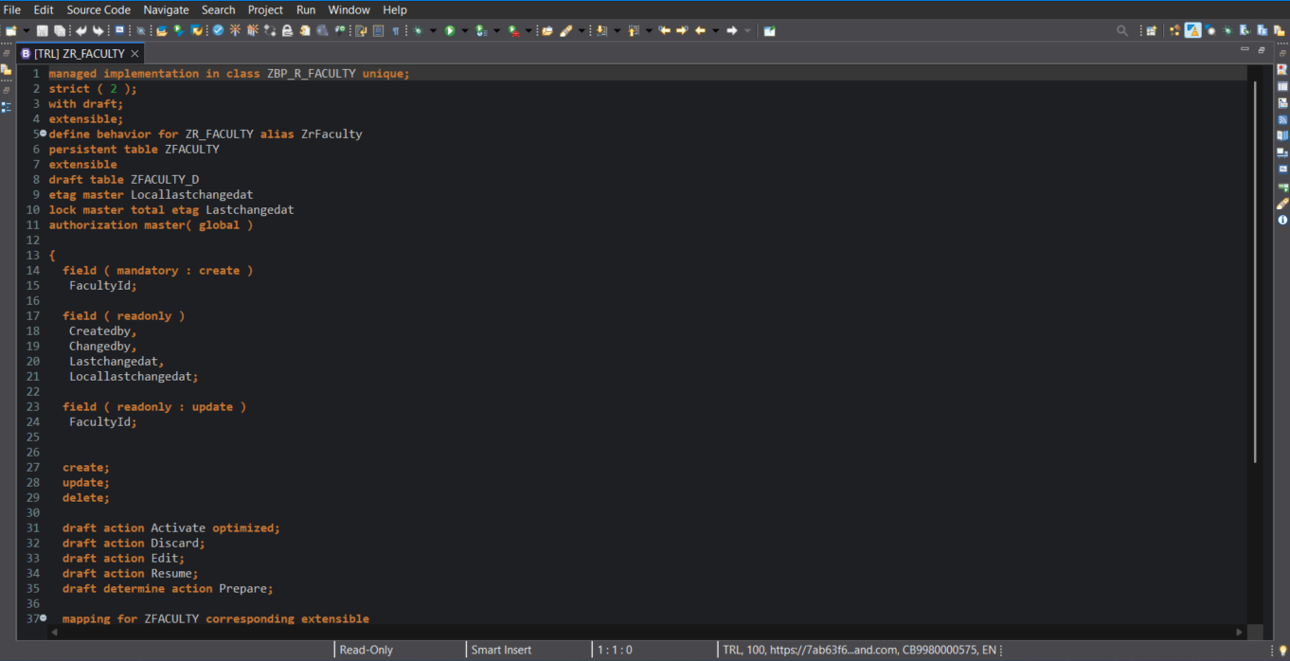

* + 1. *ZR_STUDENT_1535 – Behavior Definition for ZR_STUDENT_1535*

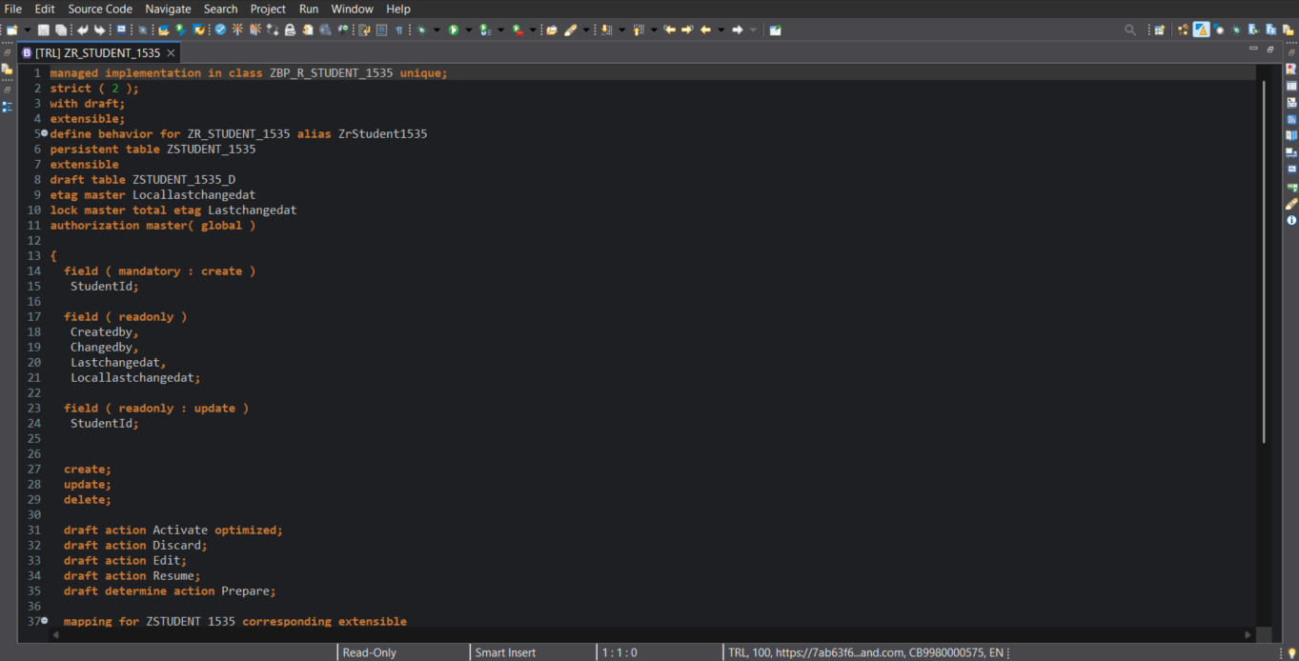

* 1. ***Projection Views (ZC_*)**
     1. *ZC_USER_LOGIN –Projection Behavior Definition for ZC_USER_LOGIN*

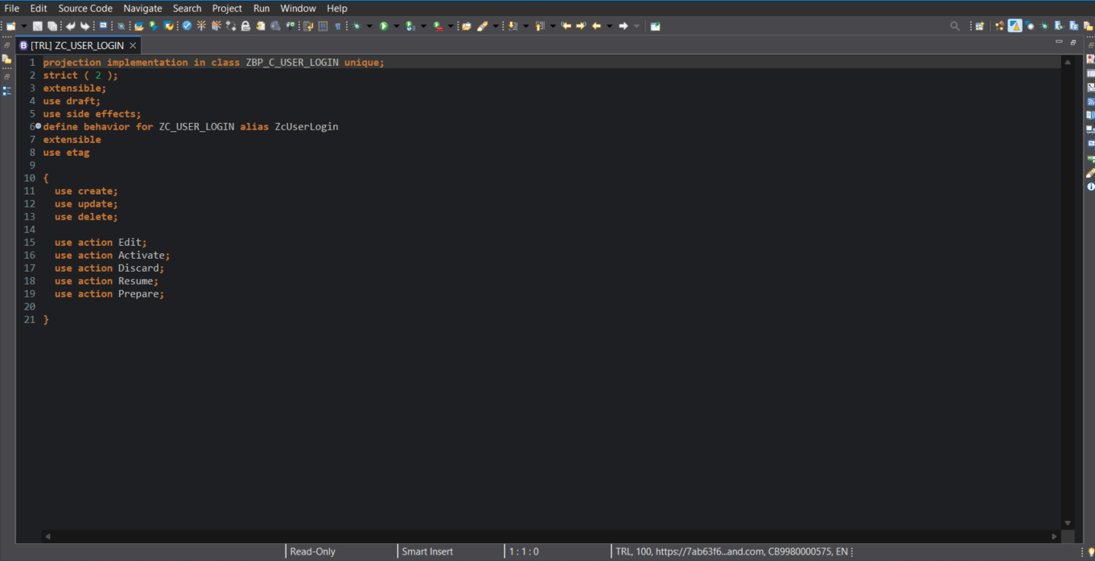

* + 1. *ZC_STUDY_MATERIAL000 – Projection Behavior Definition for ZC_STUDY_MATERIAL*

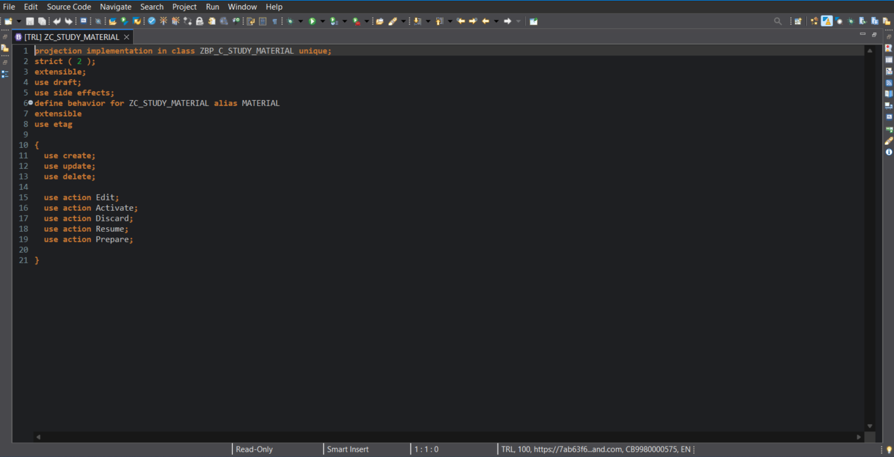

* + 1. *ZC_DEPARTMENT000 – Projection Behavior Definition for ZC_DEPARTMENT*

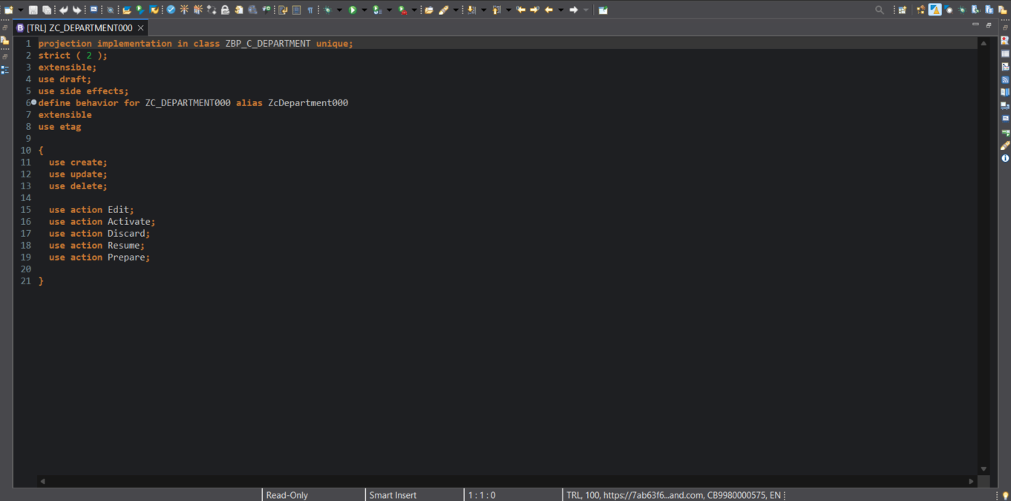

* + 1. *ZC_FACULTY– Projection Behavior Definition for ZC_FACULTY*

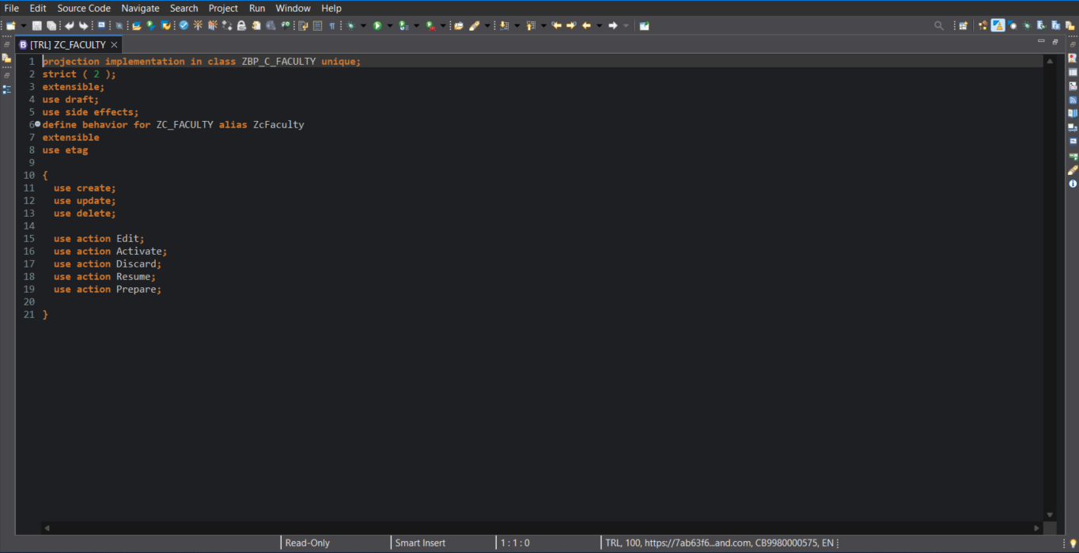

* + 1. *ZC_STUDENT_1535 – Projection Behavior Definition for ZC_STUDENT_1535*

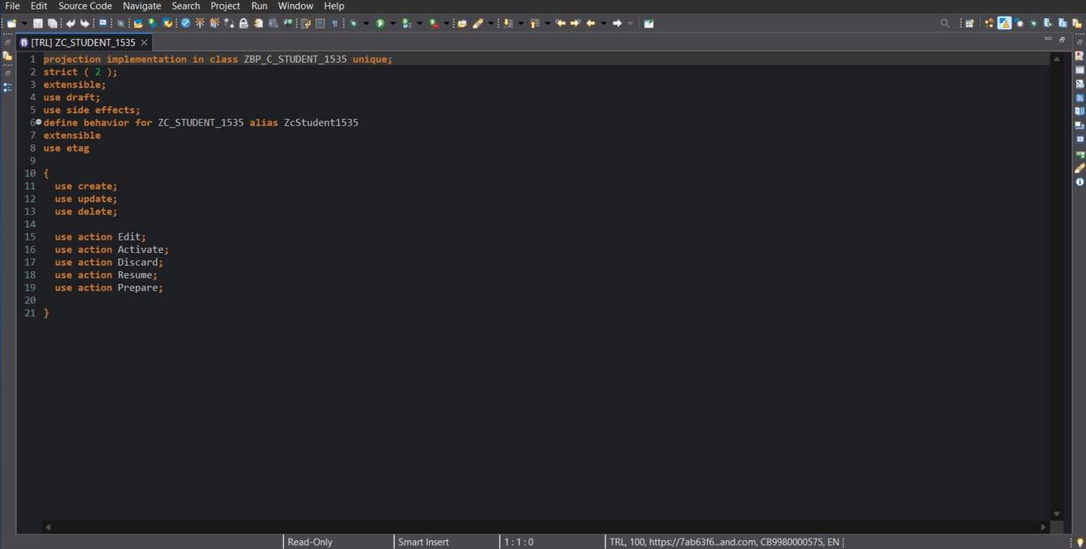

* 1. ***Metadata Extension***
     1. *ZC_USER_LOGIN –Metadata Extension for ZC_USER_LOGIN*

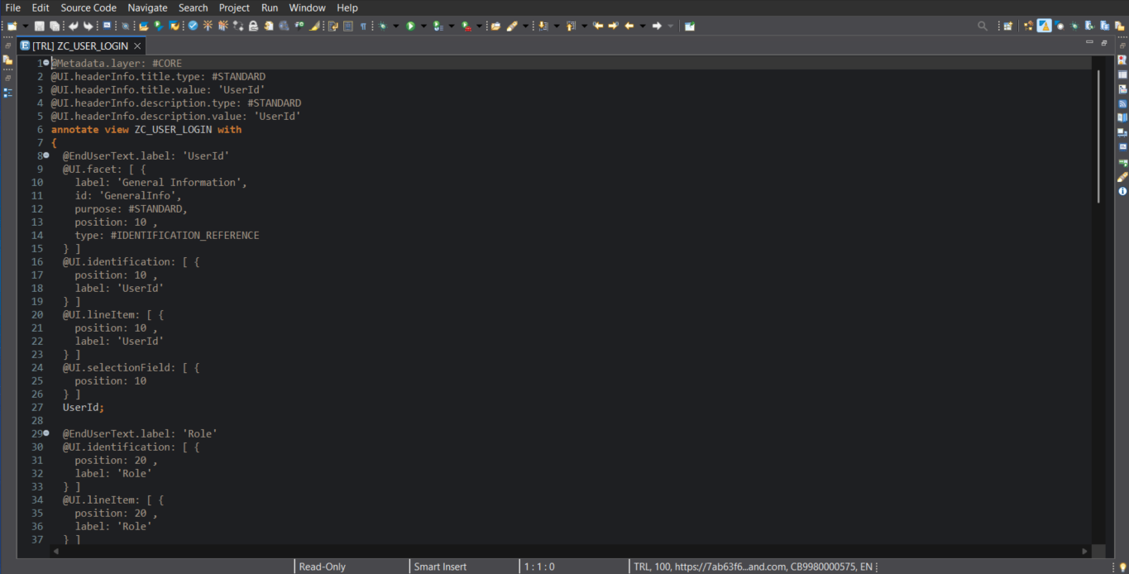

* + 1. *ZC_STUDY_MATERIAL000 – Metadata Extension for ZC_STUDY_MATERIAL*

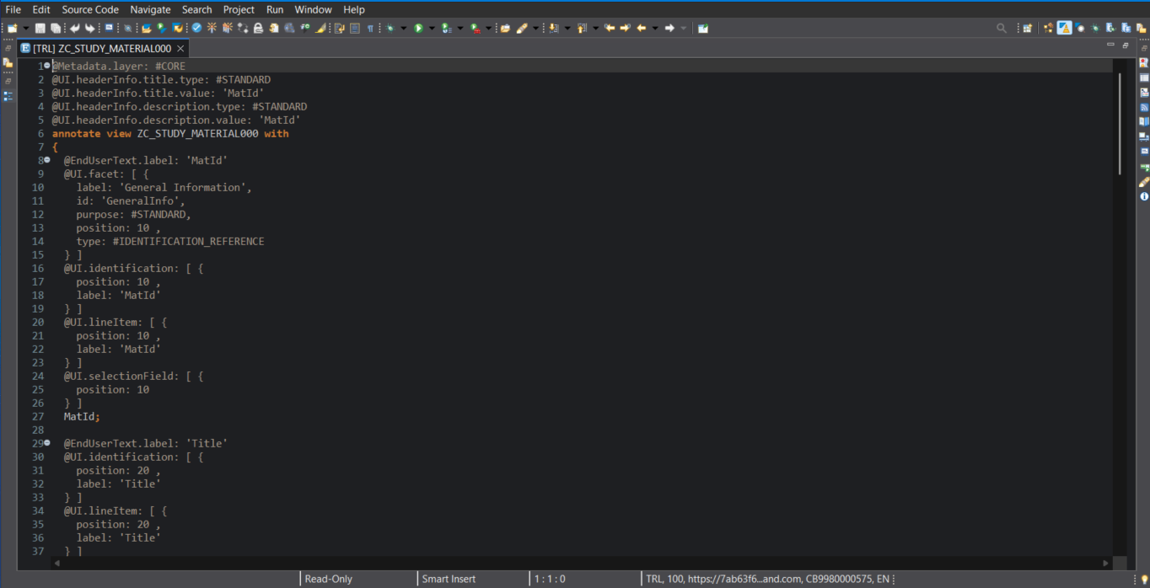

* + 1. *ZC_DEPARTMENT000 – Metadata Extension Definition for ZC_DEPARTMENT*

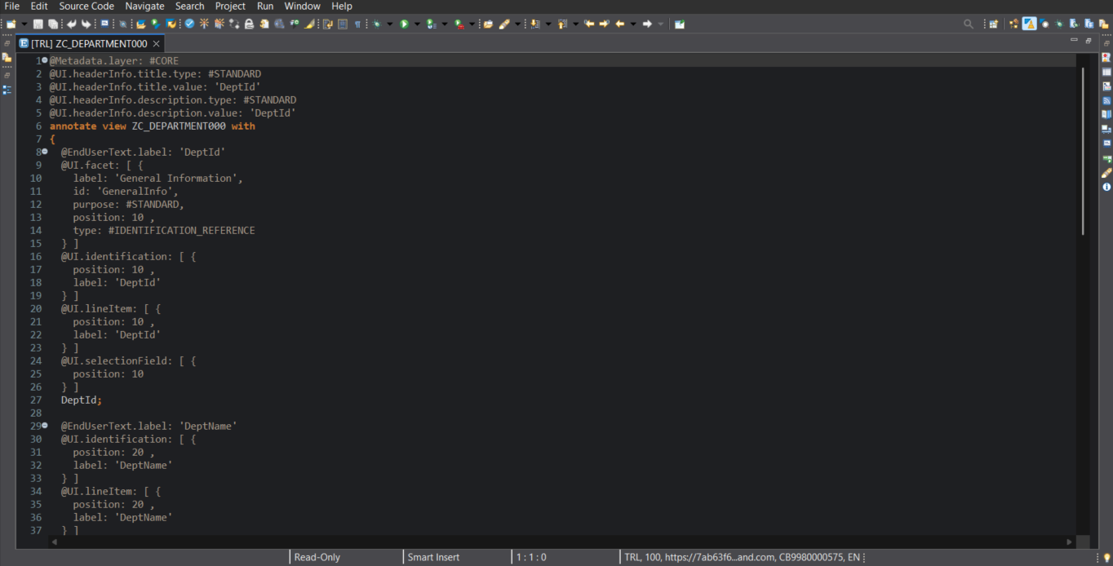

* + 1. *ZC_FACULTY– Metadata Extension for ZC_FACULTY*

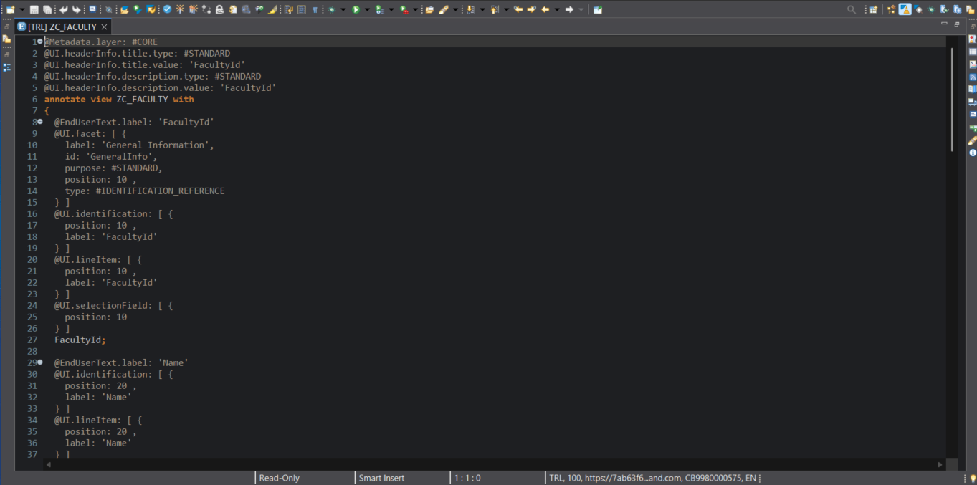

* + 1. *ZC_STUDENT_1535 – Metadata Extension for ZC_STUDENT_1535*

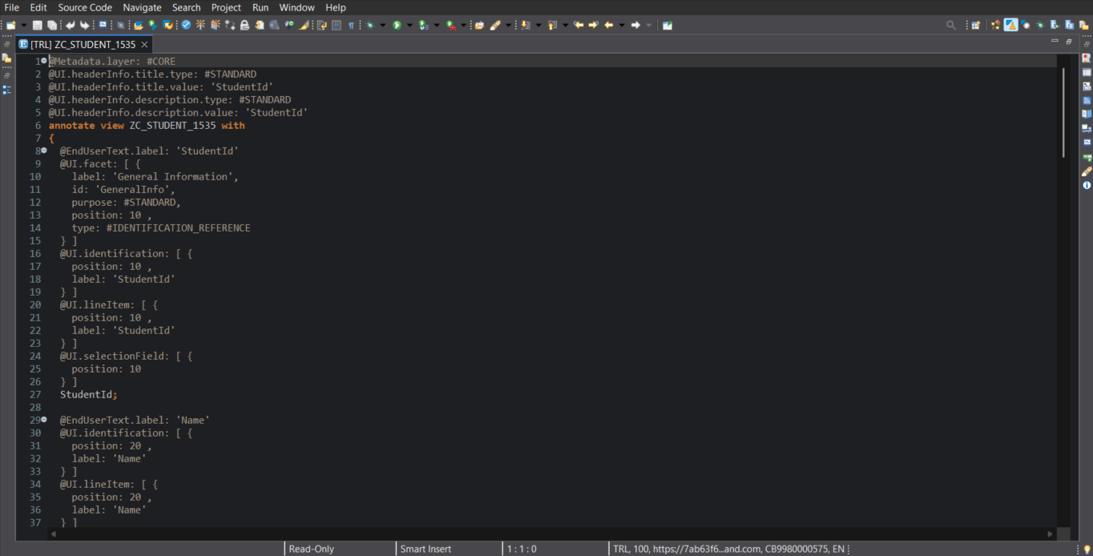

#### RESTful Implementation Linked to Specific Tables (Preview)

1. *User Login Details*

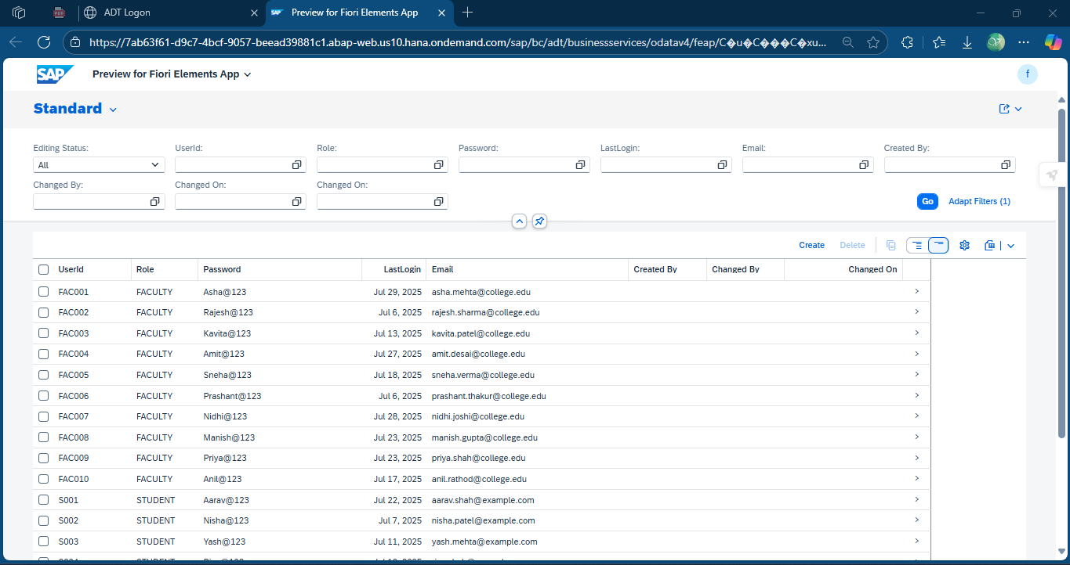

* *Create*

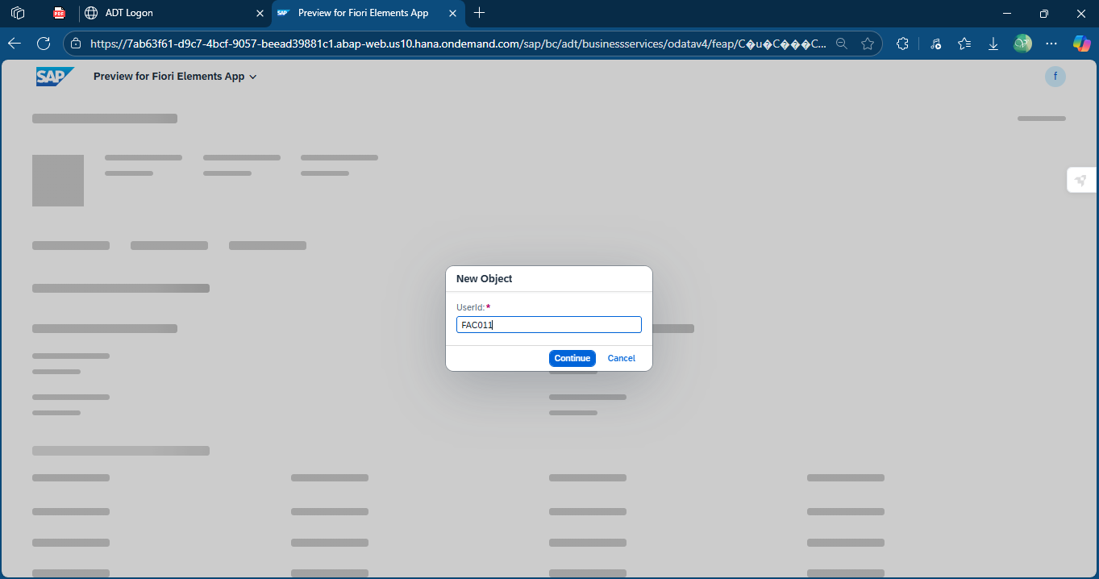

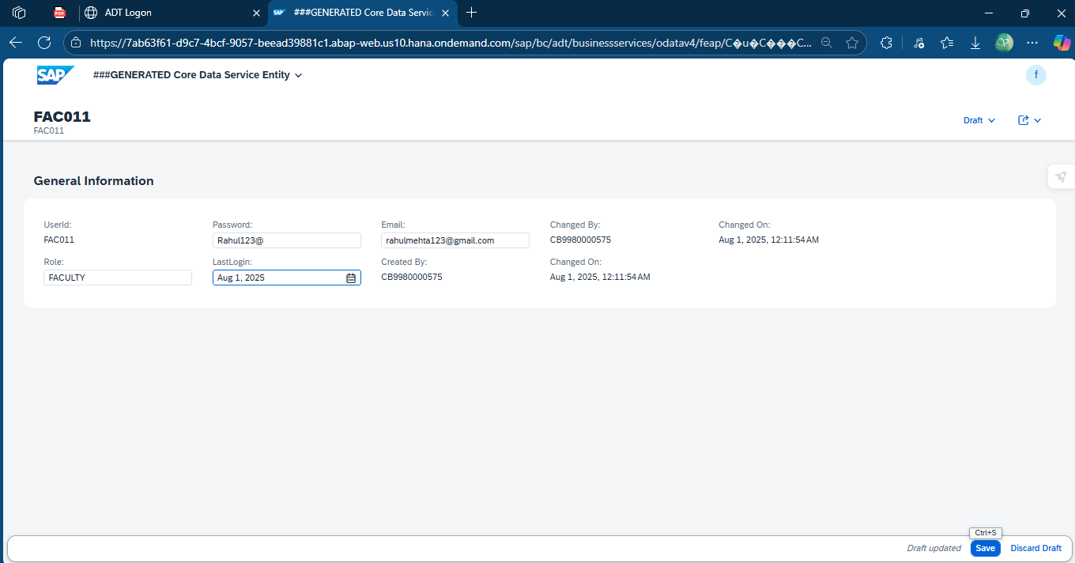

* *Read*

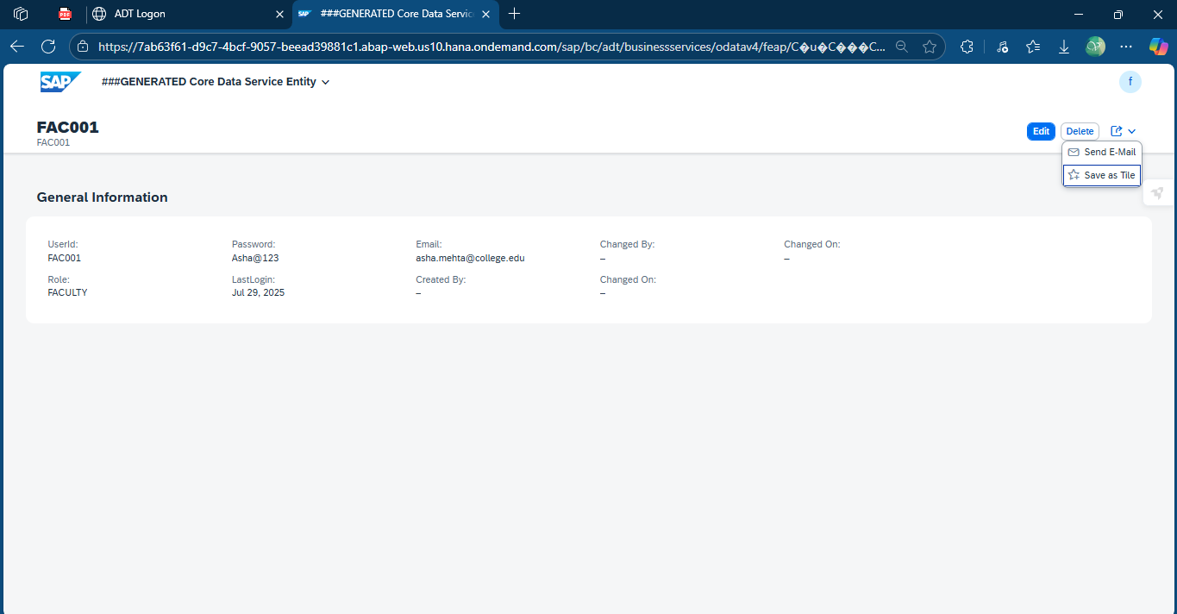

* *Update*

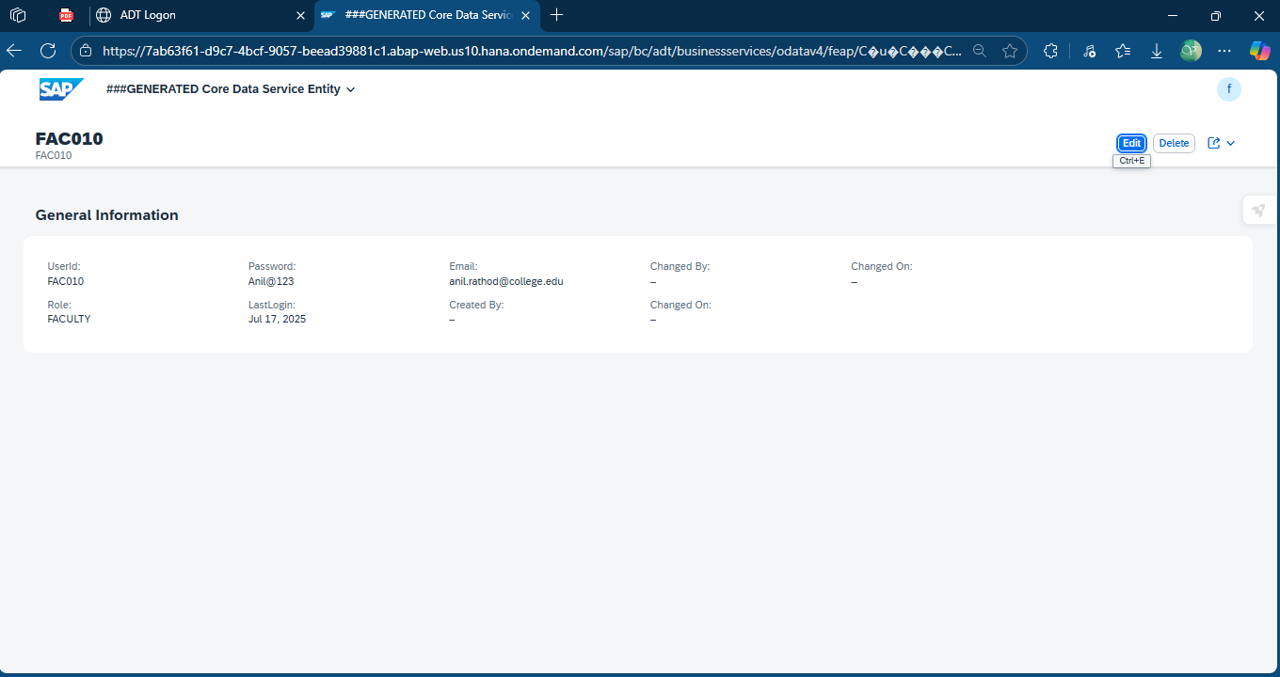

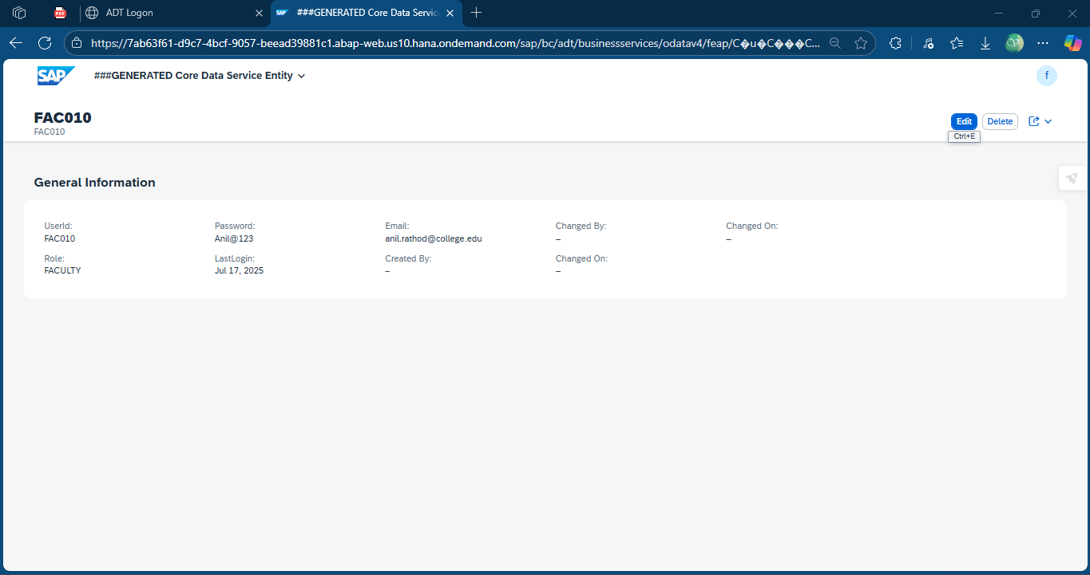

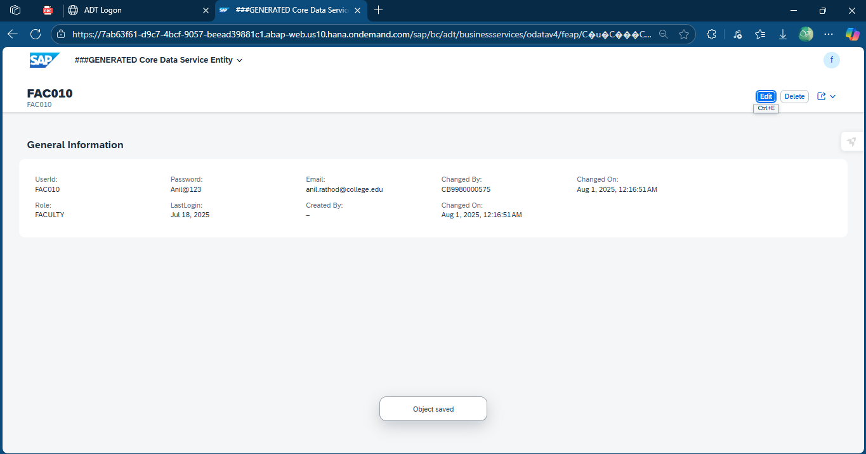

* *Delete*

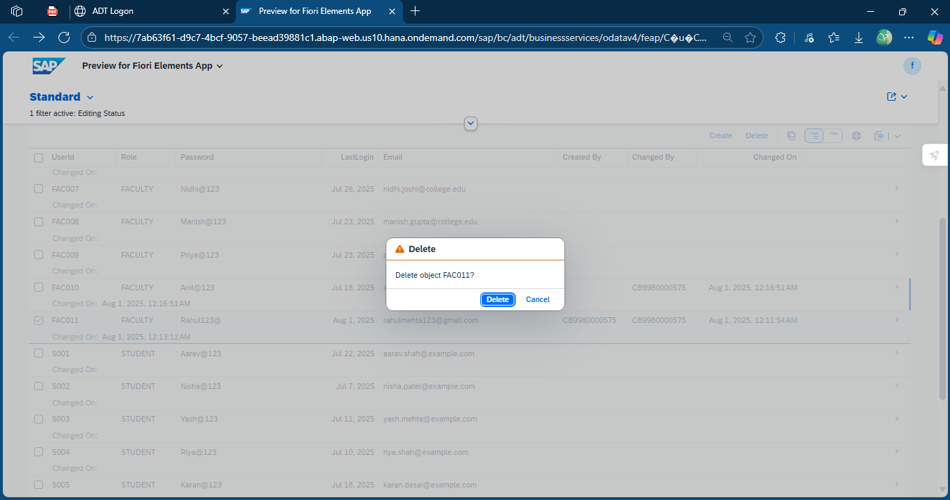

1. *Study Material Details*

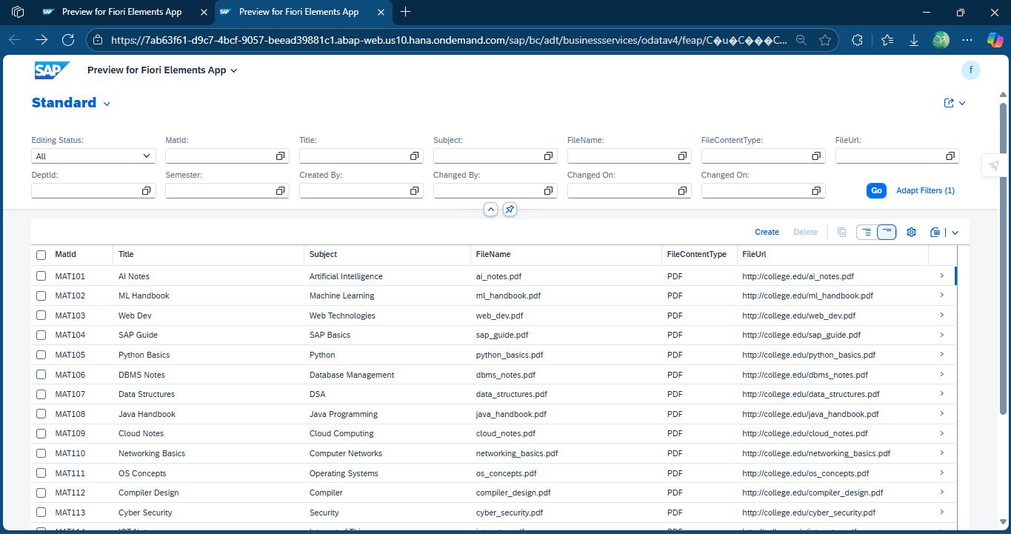

* *Create*

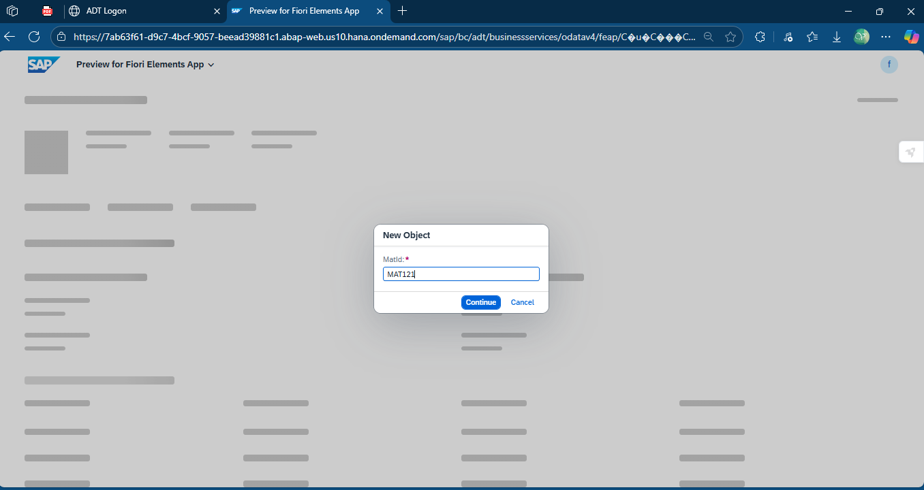

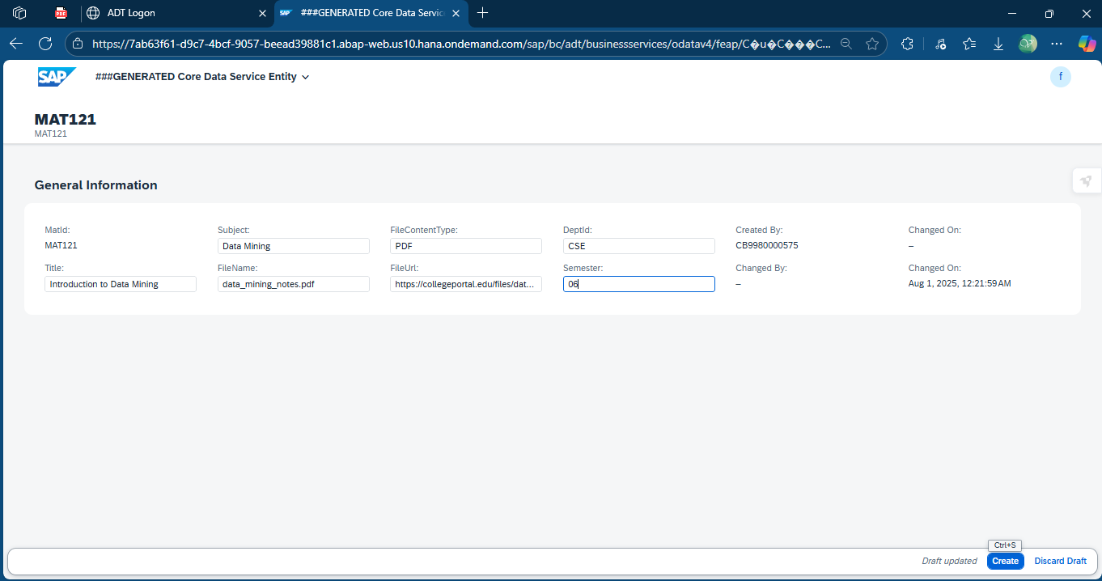

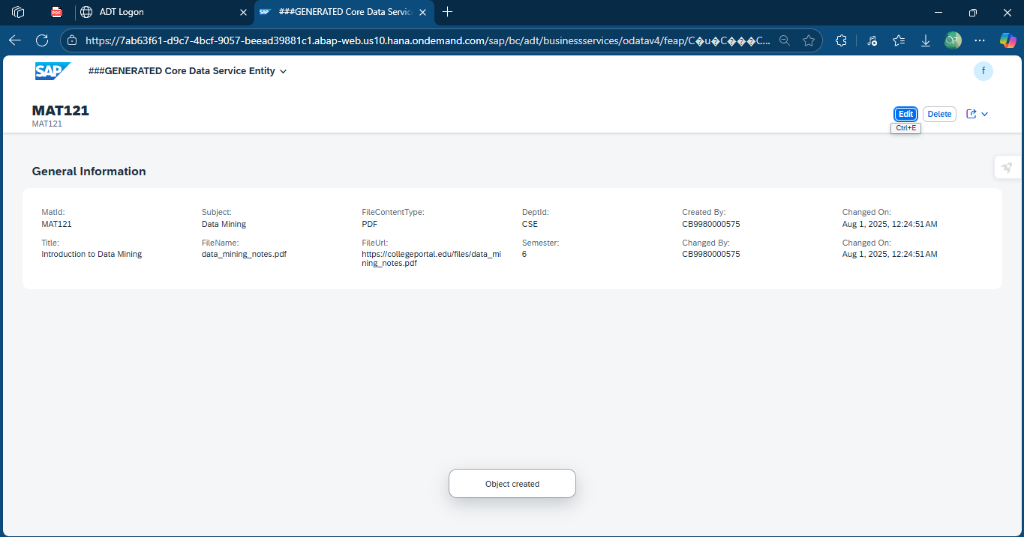

* *Read*

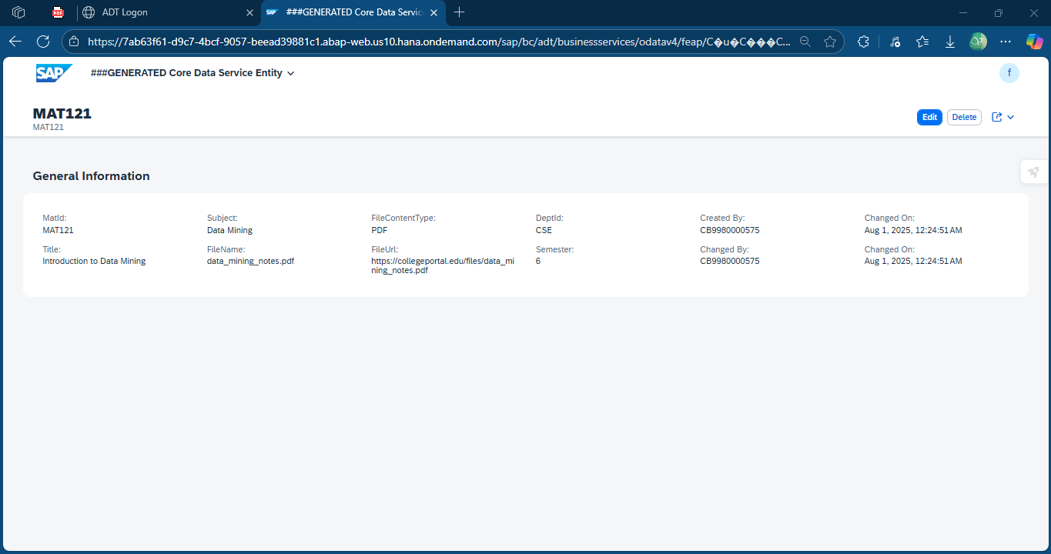

* *Update*

**

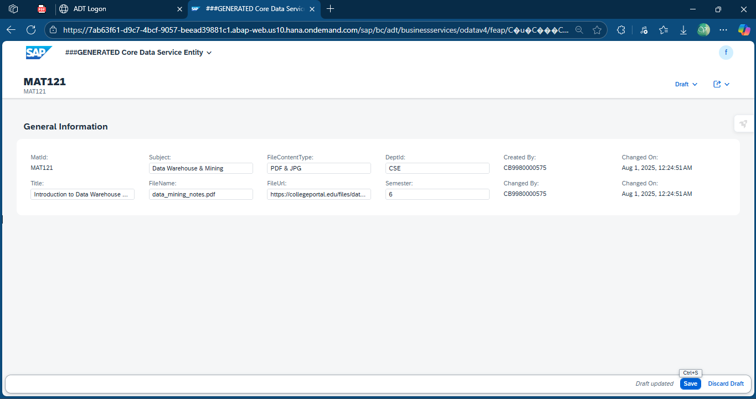

* *Delete*

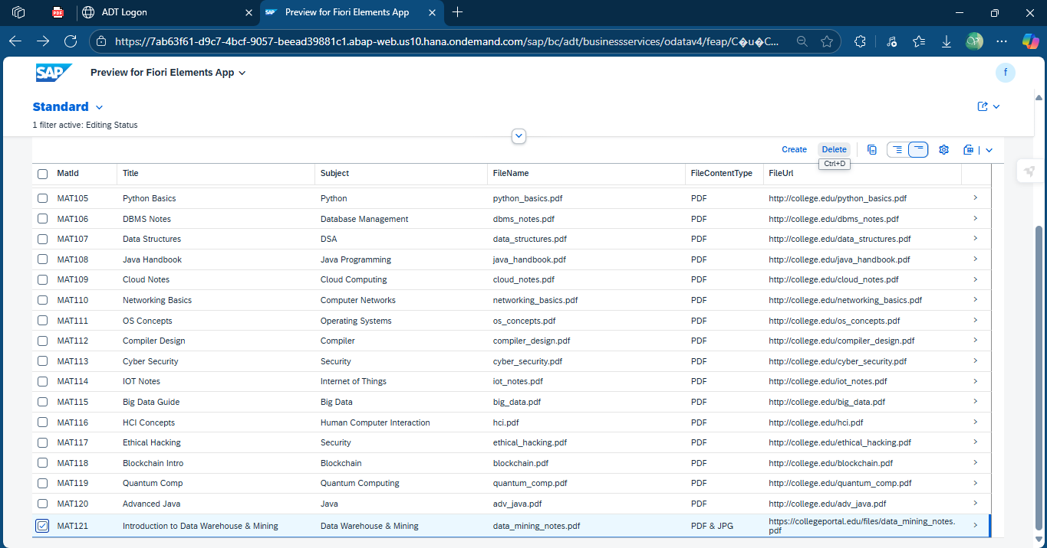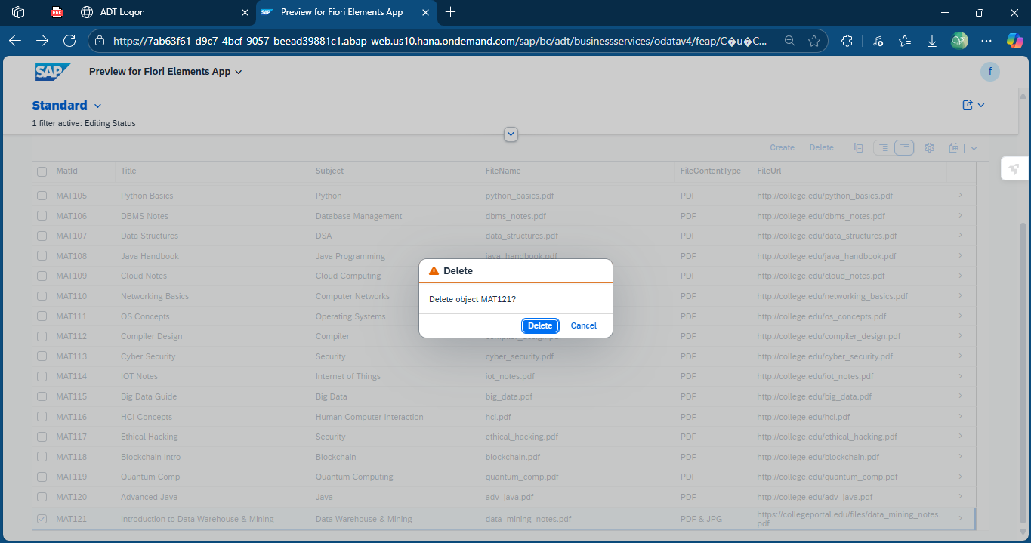

1. *Department Details*

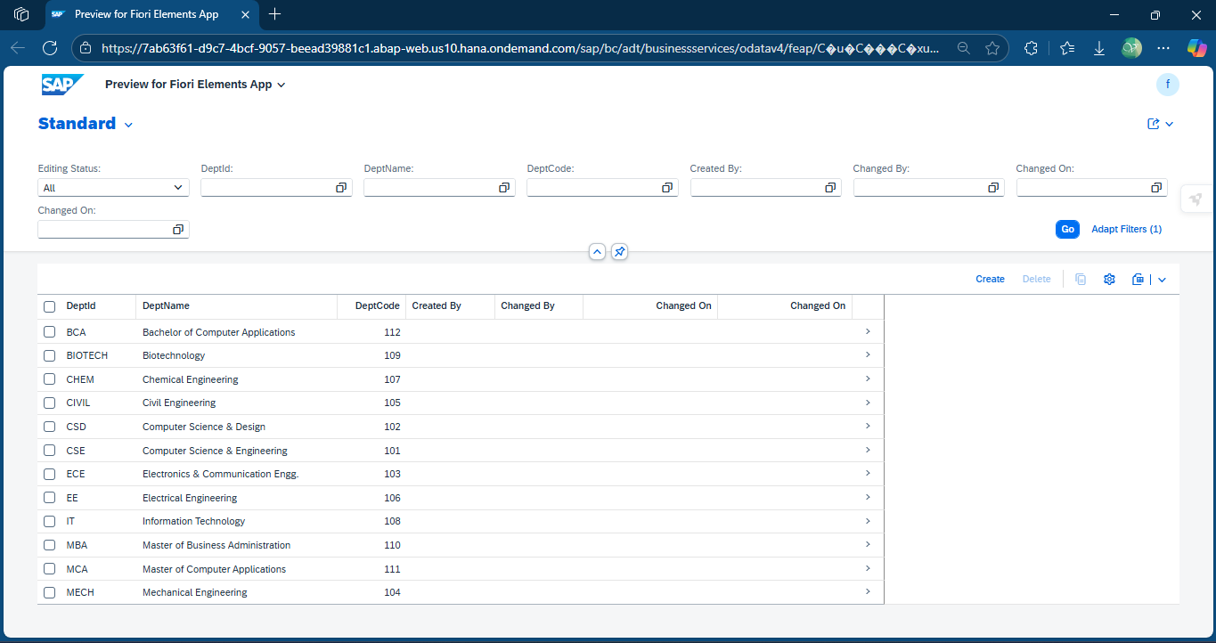

* *Create*

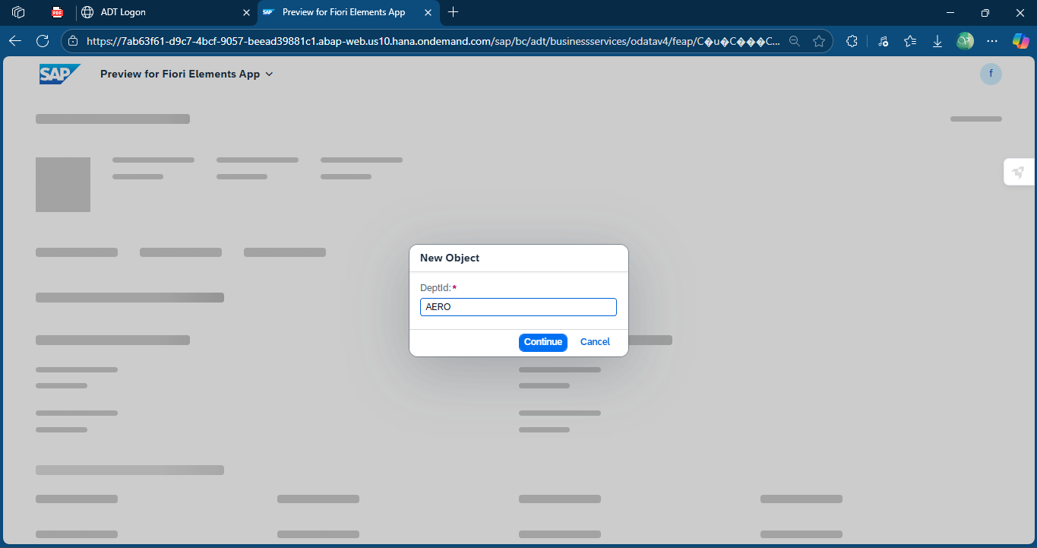

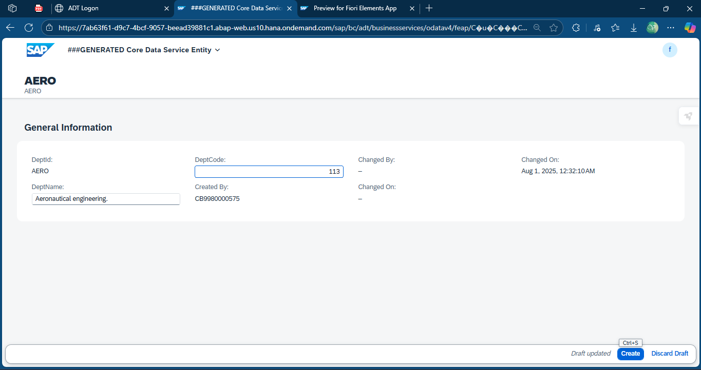

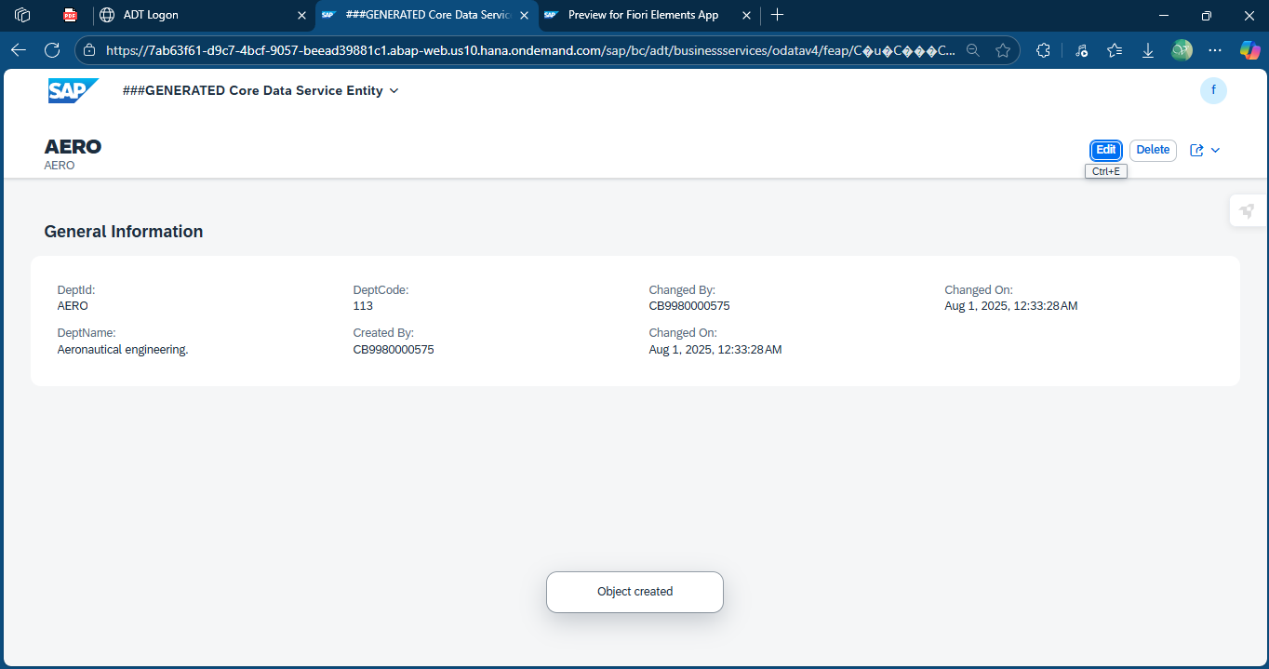

* *Read*

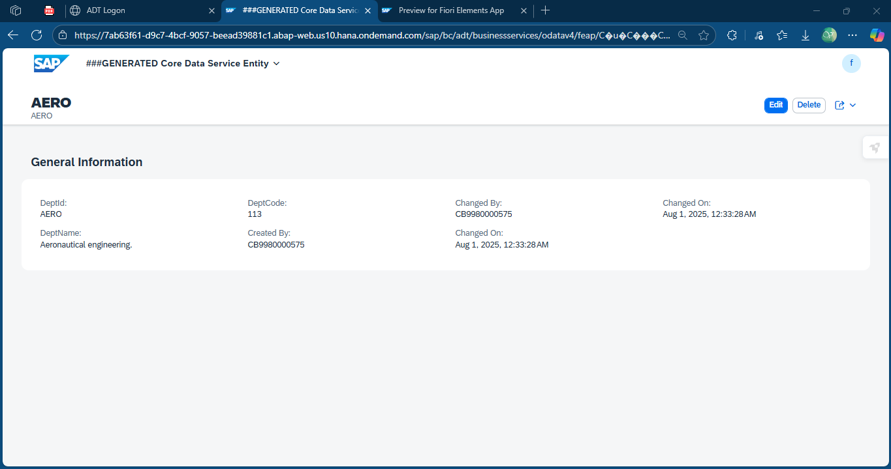

* *Update*

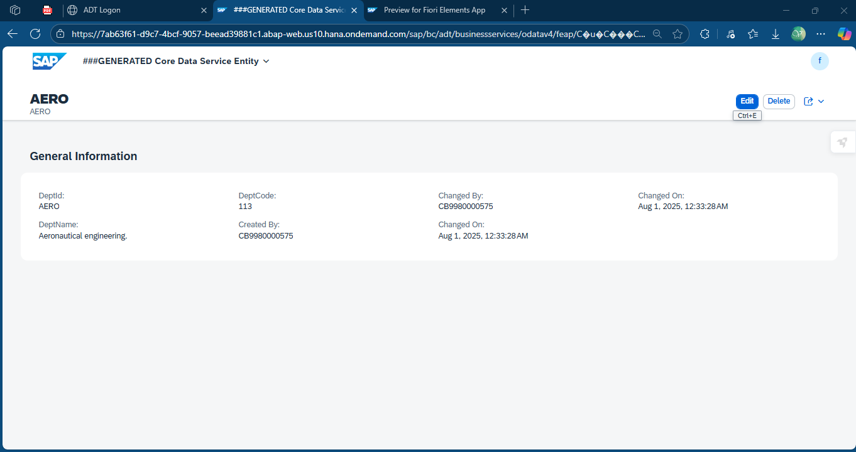

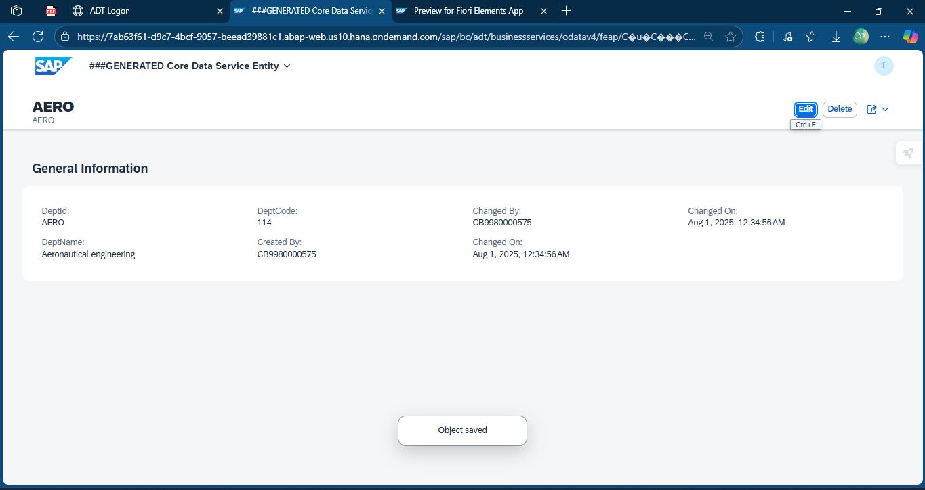

* *Delete*

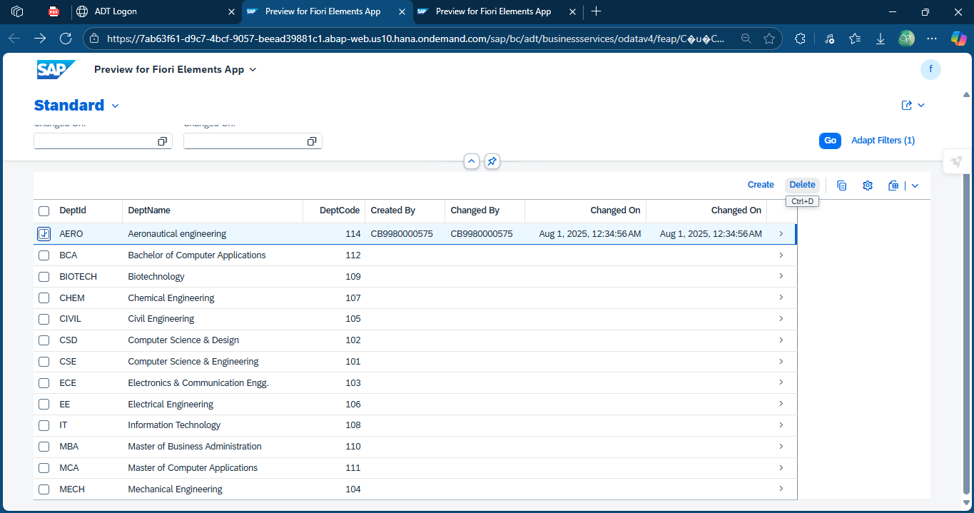

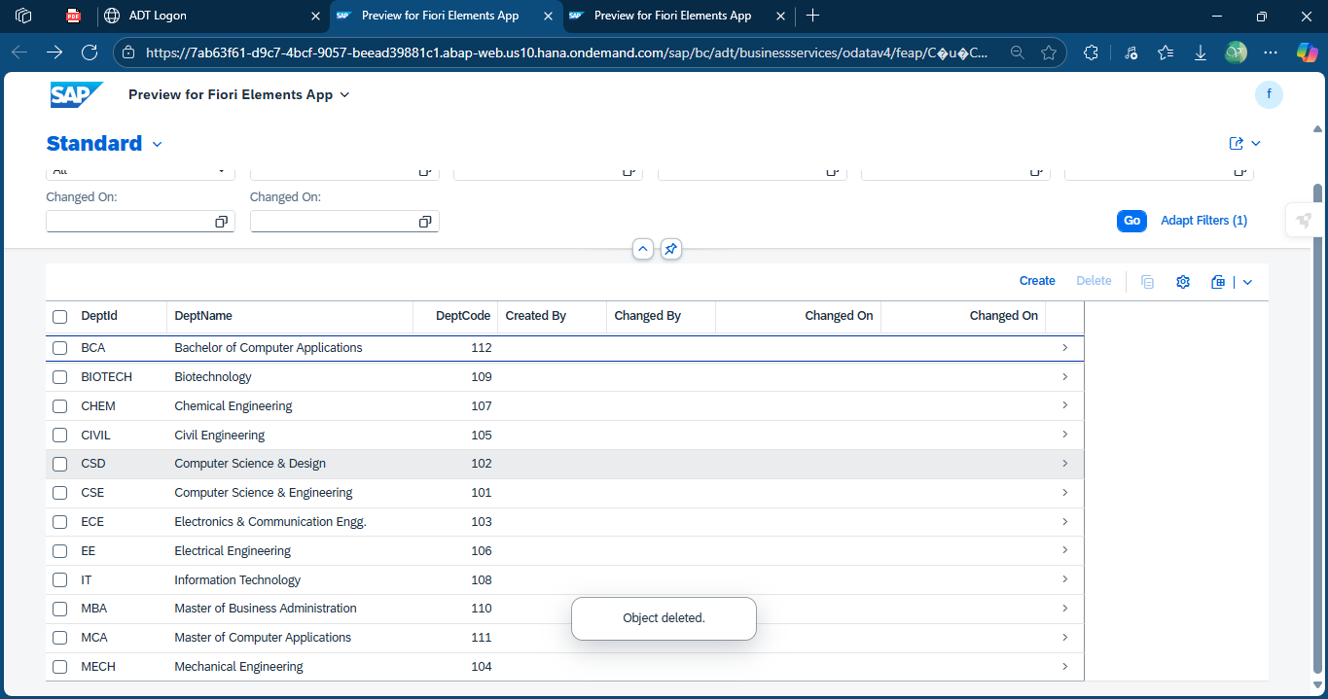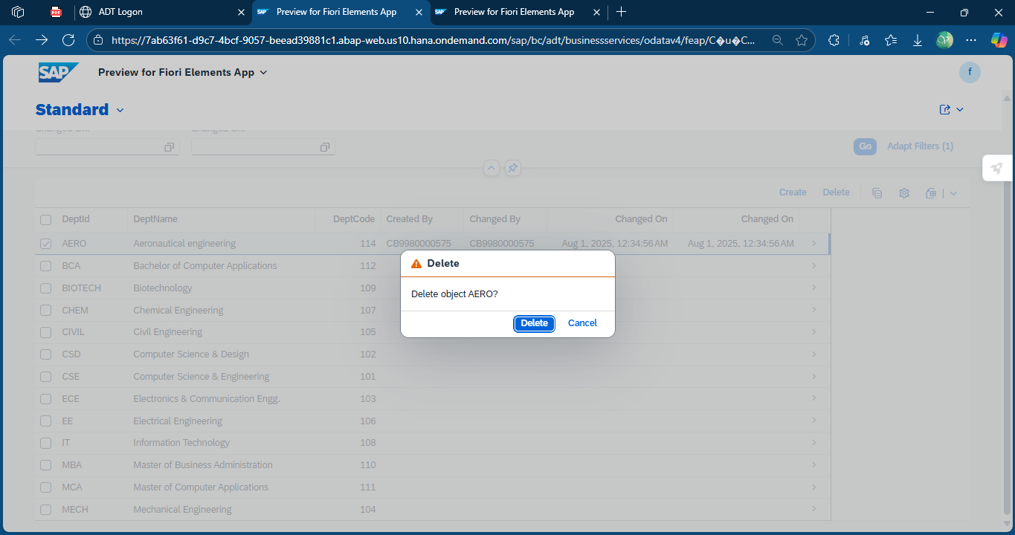

1. *Faculty Details*

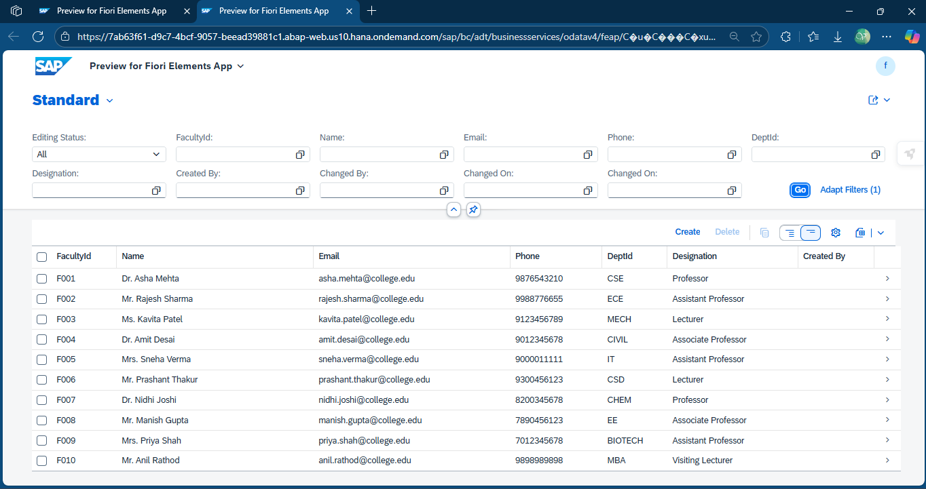

* *Create*

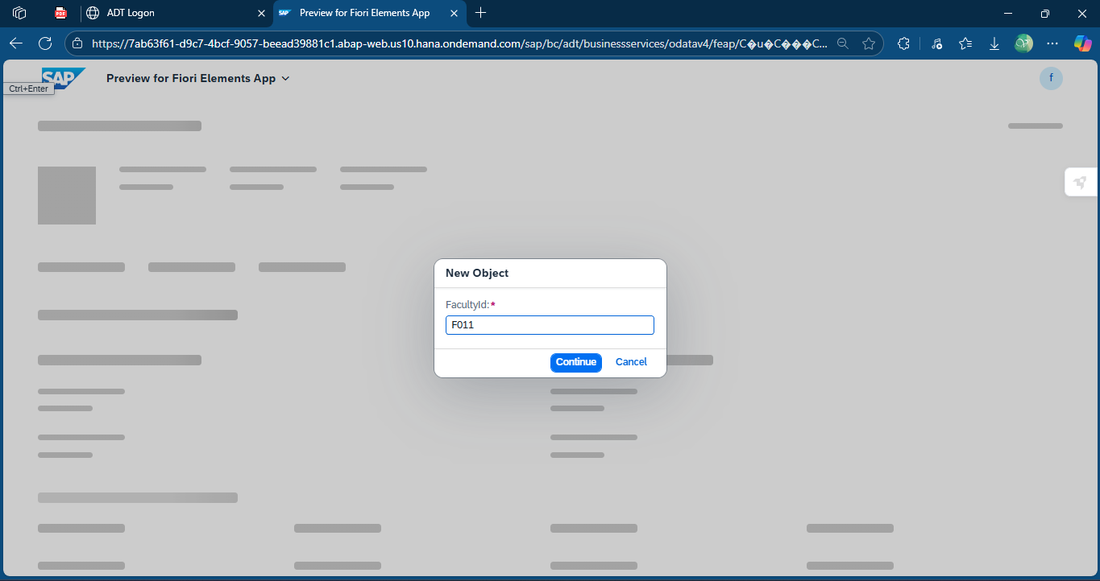

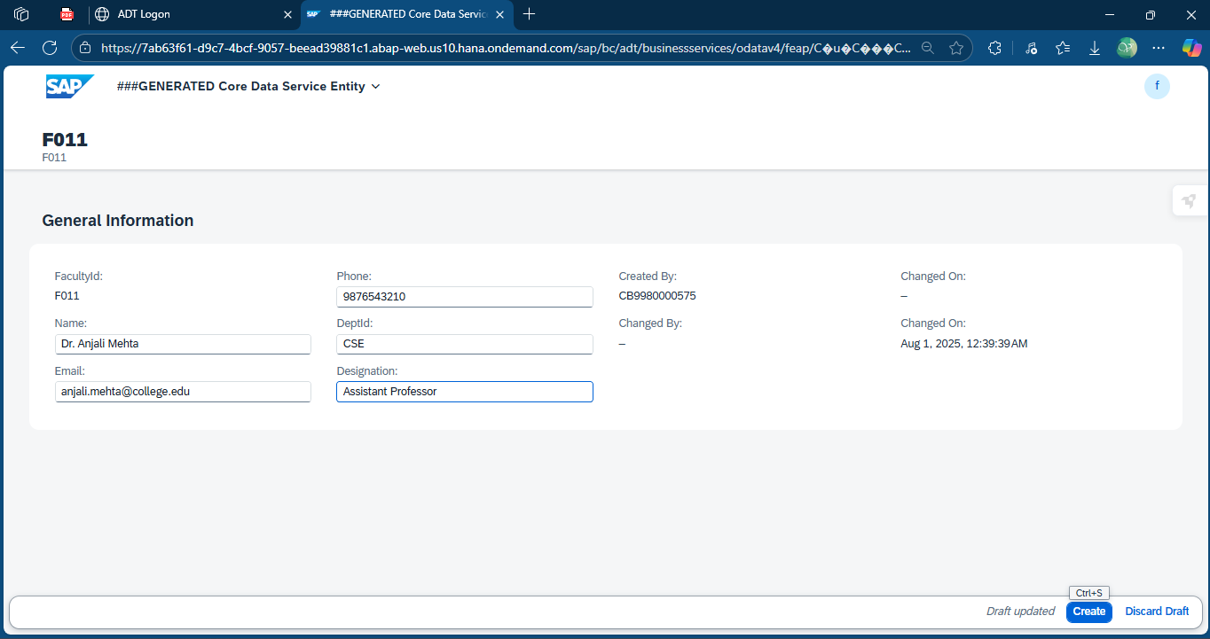 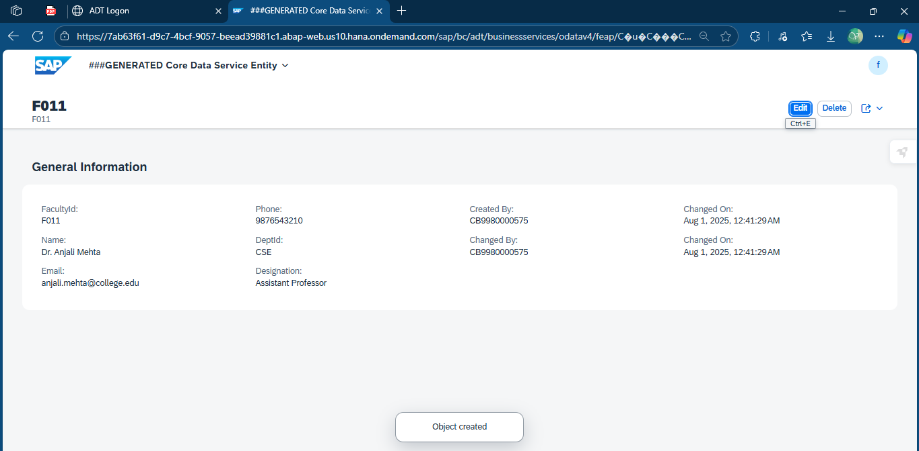

* *Read*

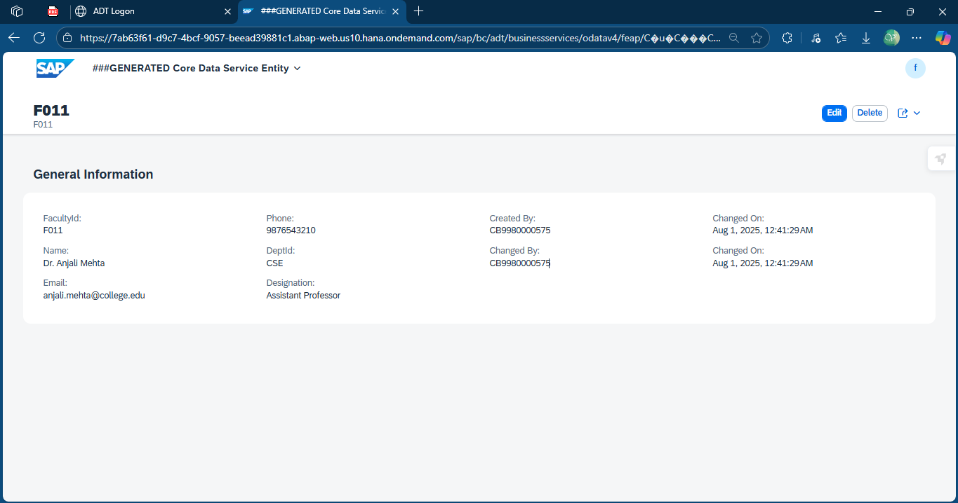

* *Update*

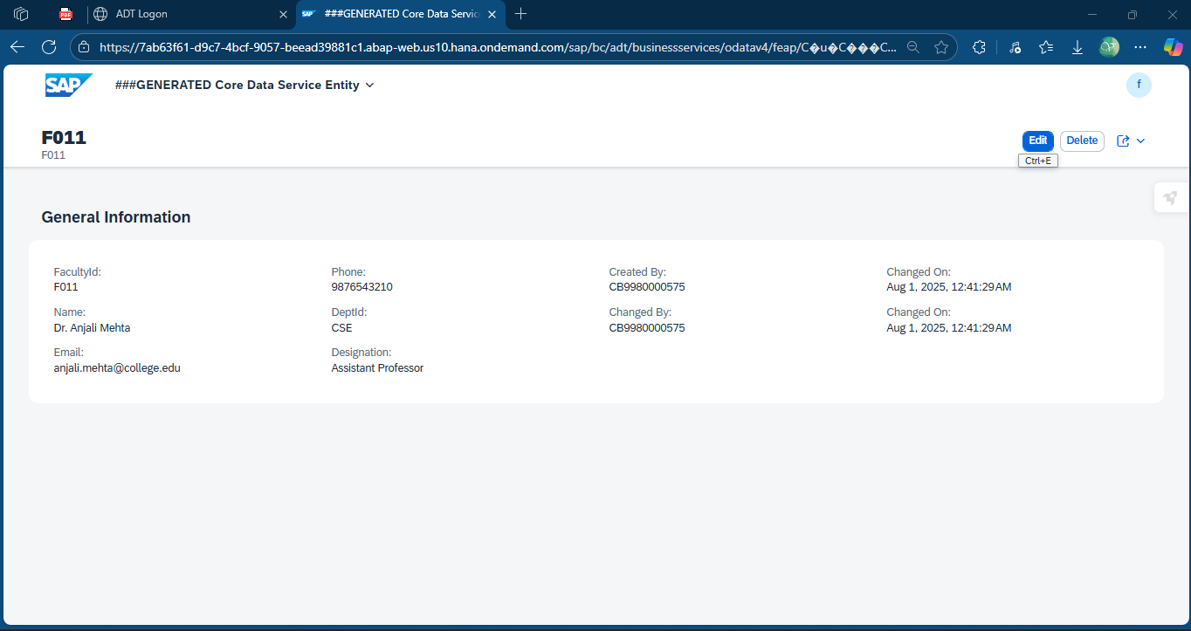

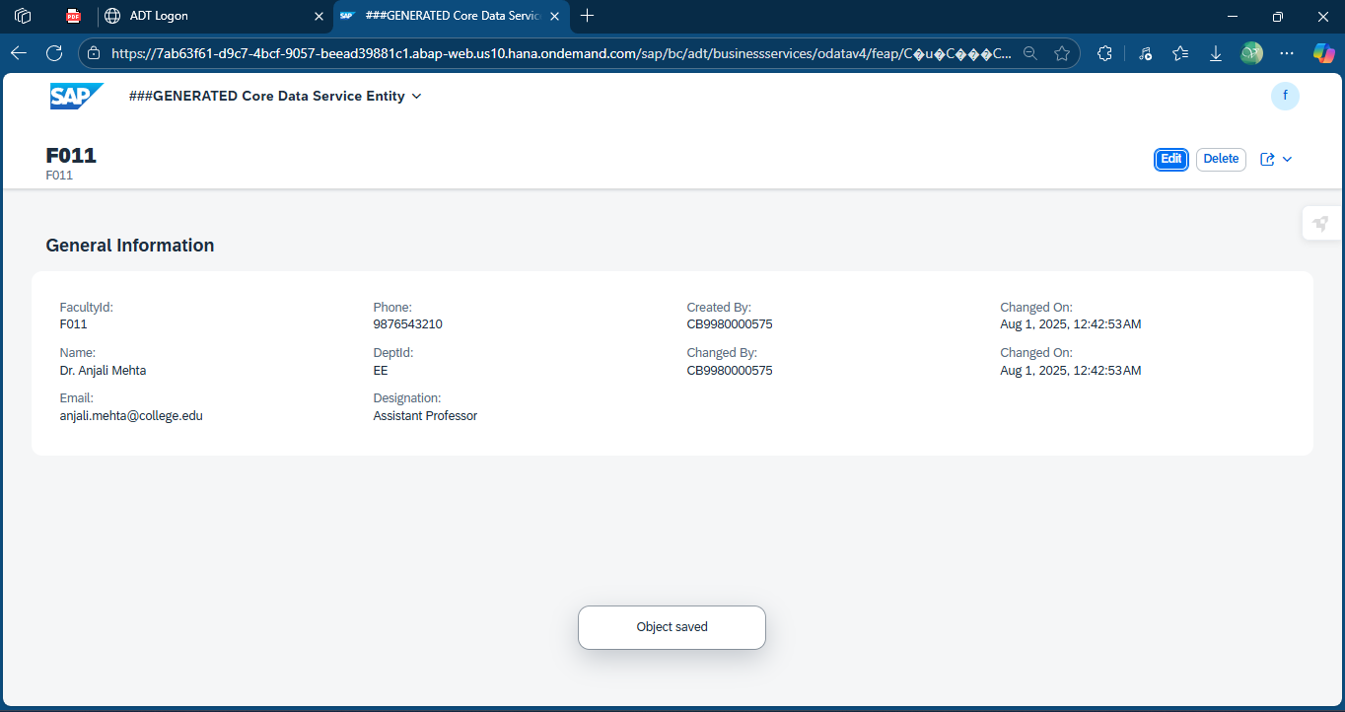

* *Delete*

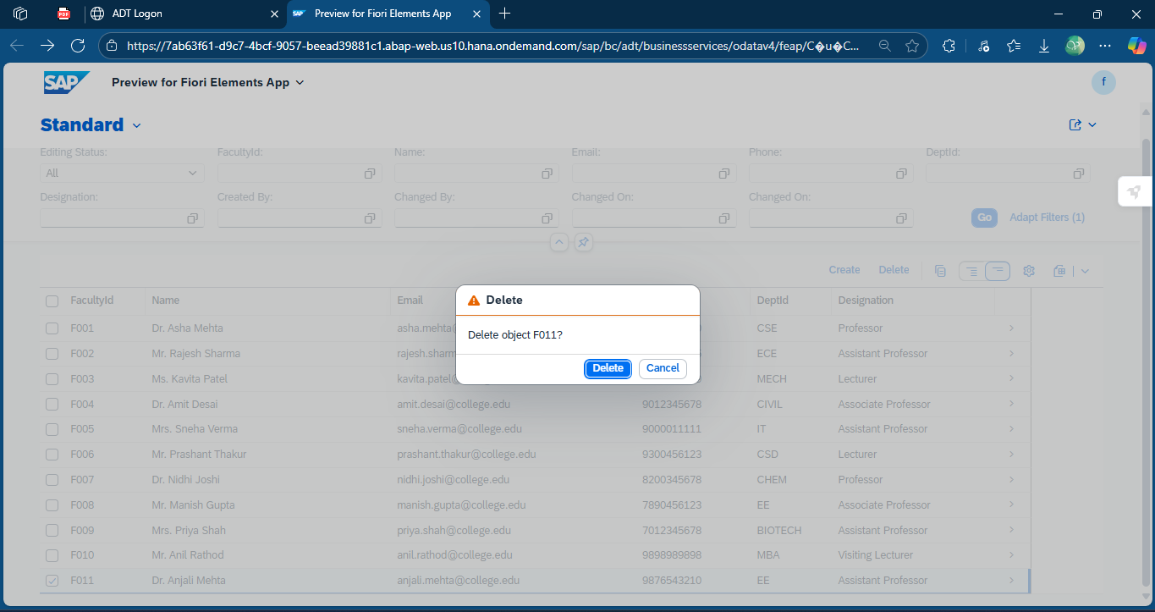

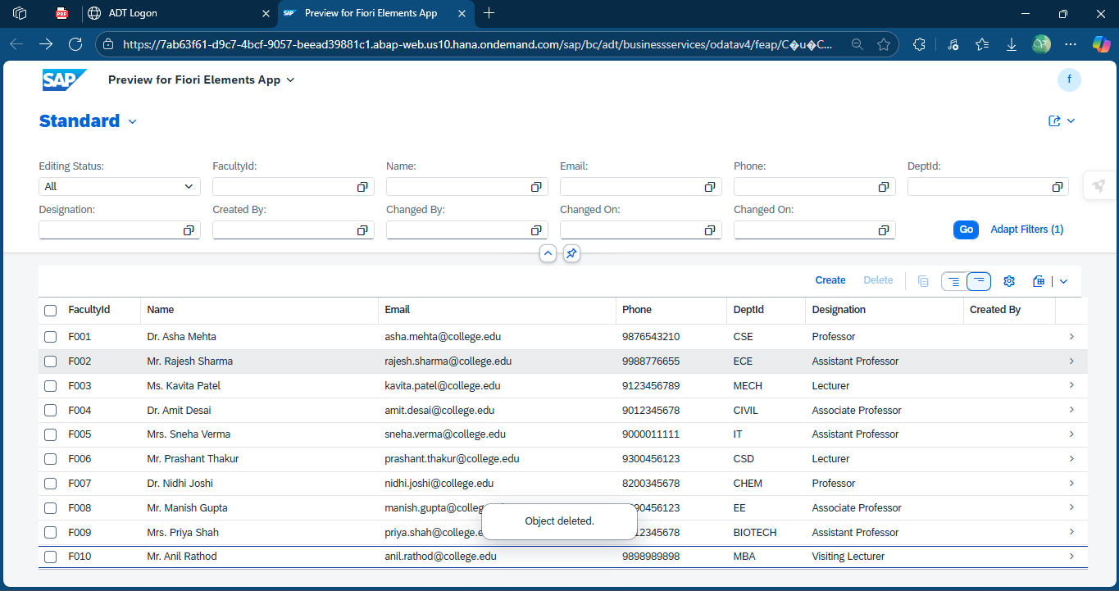

1. *Student Details*

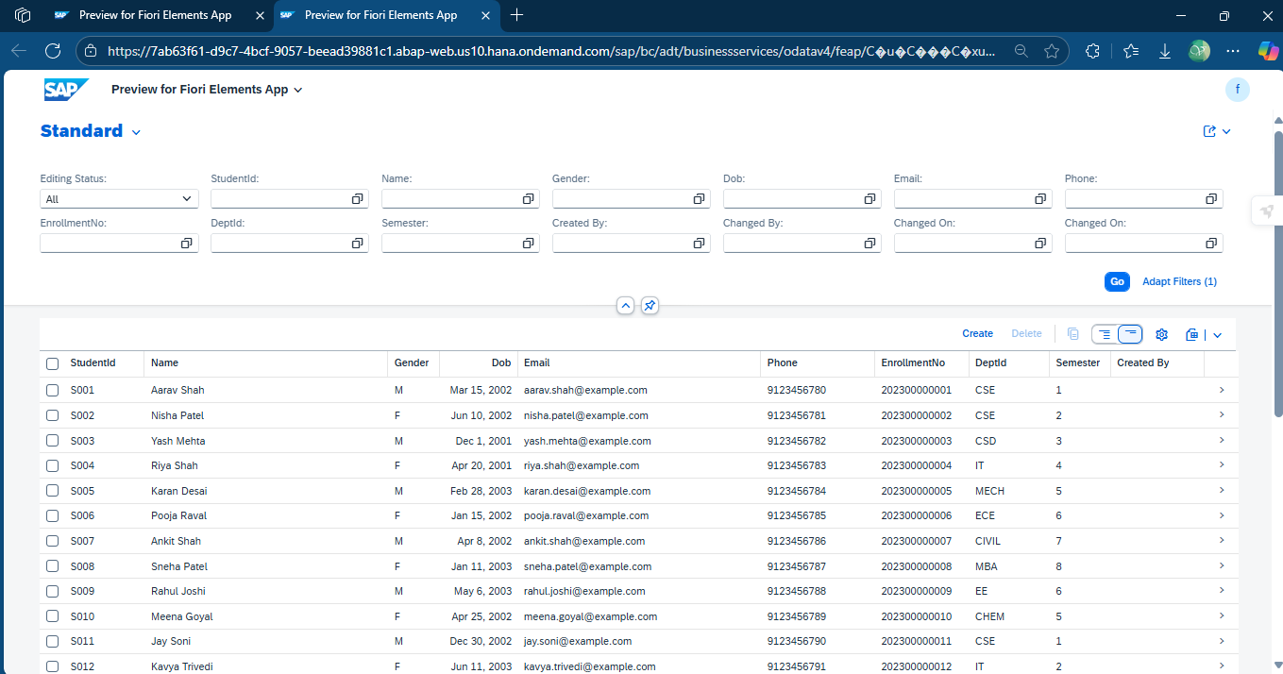

* *Create*

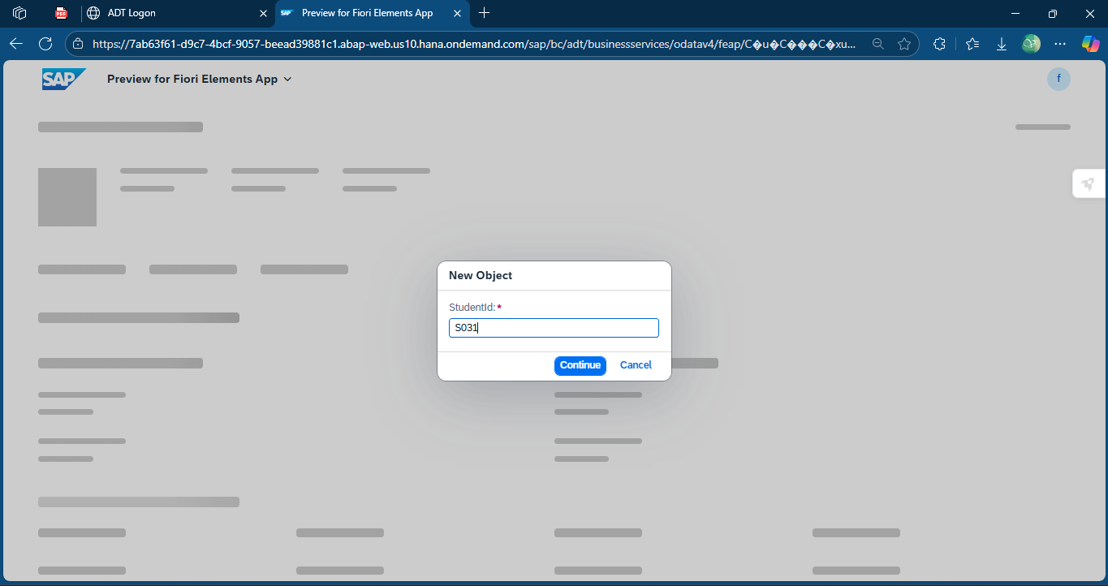

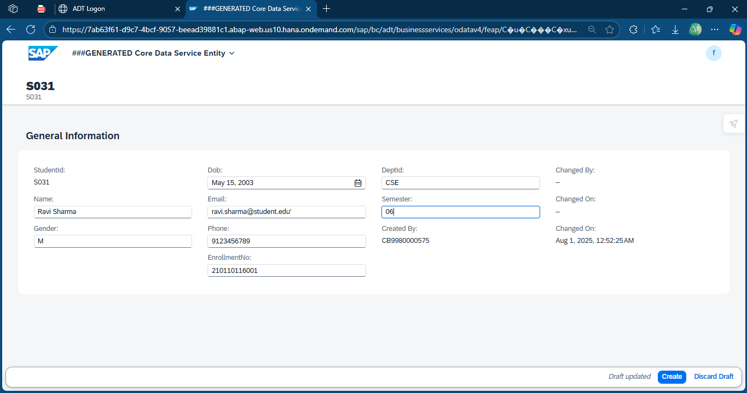

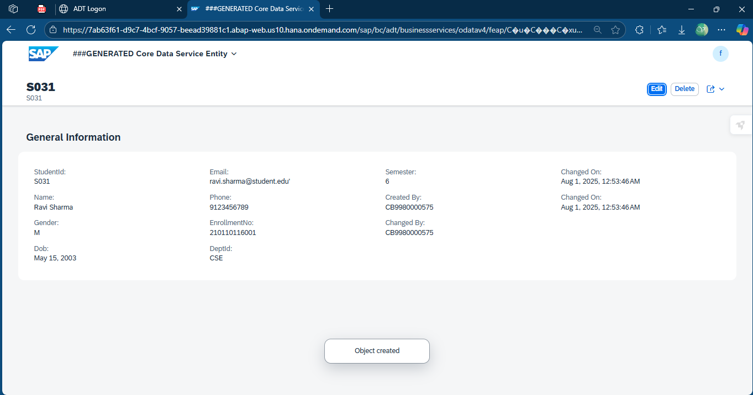

* *Read*

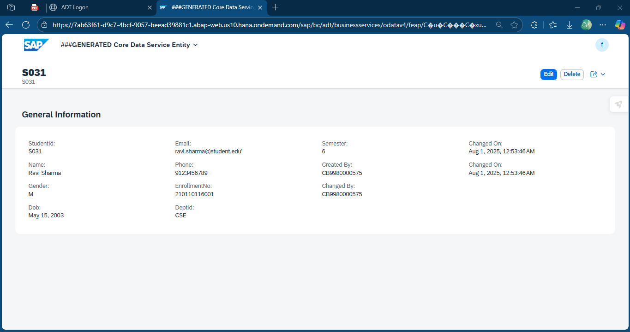

* *Update*

**

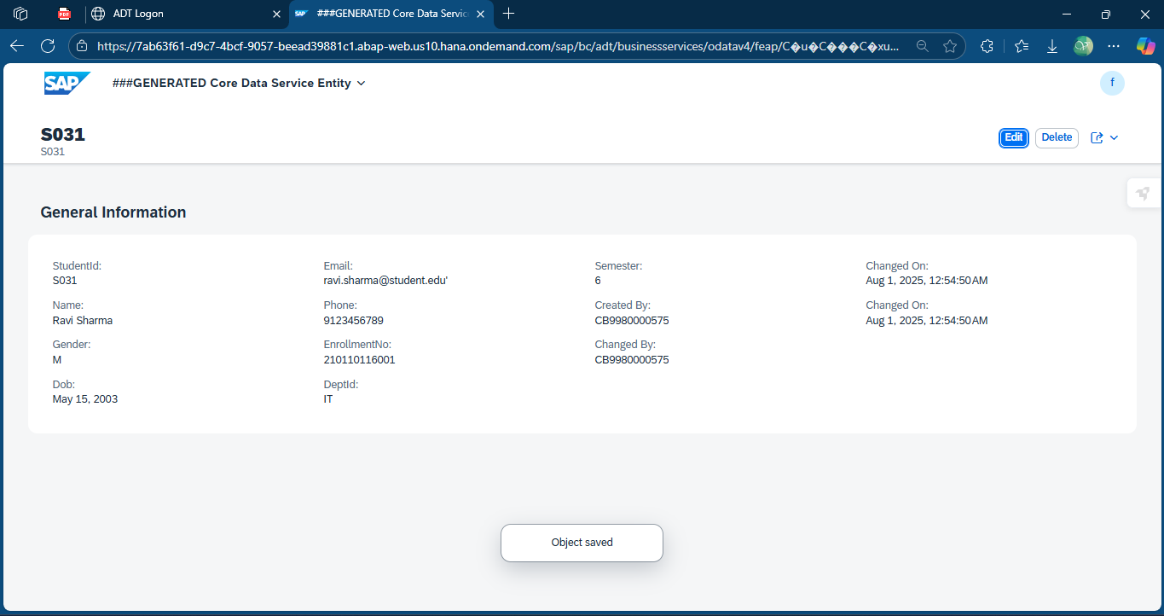

* *Delete*

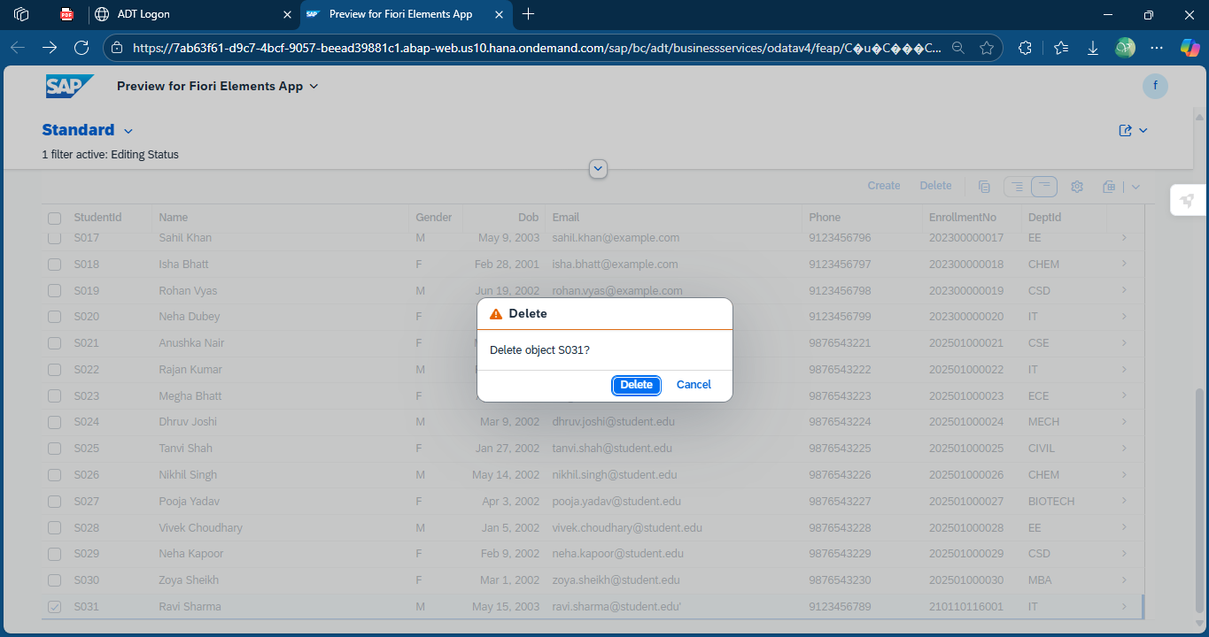

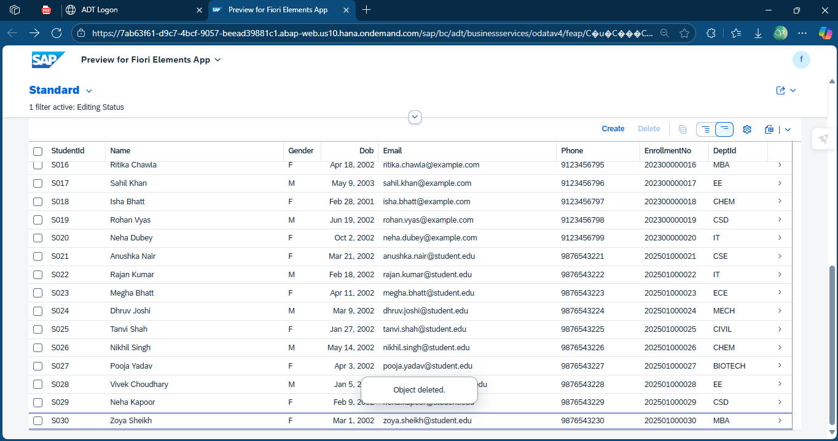

**8. Final Outcome**

The final outcome of this project is a fully functional **SAP-based College Study Material Management System**. It enables students and faculty to **log in securely**, **upload**, **access**, and **manage academic materials** such as notes, assignments, and lecture slides. The project integrates various ABAP functionalities such as **join operations, aggregate functions, subqueries, and in-built functions** using **Code Pushdown** with SAP HANA. It supports **role-based access**, clean data storage through **transparent tables**, and is compliant with SAP’s best practices using CDS views and custom classes.

**9. Conclusion**

This project demonstrates how SAP ABAP and HANA capabilities can be utilized to build a scalable and secure **college academic portal**. By implementing real-time features like login management, department-wise material distribution, and faculty-student interaction, the solution supports **digital education initiatives** effectively. The use of **modular design, best data practices, and performance-focused development** ensures that the system is both maintainable and extensible for future enhancements.

1. **References**

• SAP Help Portal – ABAP RESTful Application Programming Model (RAP)

<https://help.sap.com/docs/abap-restful-application-programming>

• SAP Business Technology Platform Trial

<https://cockpit.hanatrial.ondemand.com/>

• SAP ABAP Development Tools (ADT) for Eclipse

<https://tools.hana.ondemand.com/>

• CDS Views in ABAP Cloud

<https://community.sap.com>

• SAP Developer Tutorials – RAP

<https://developers.sap.com/group.abap-env-restful.html>

.